Hypernews and the problem of objectivity

Martin Engebretsen

Agder University College, Faculty of Art

ABSTRACT
Can hypertext contibute to the development of a more objective mediation of news? The aim of my position statement is to justify such a belief. The first step is to propose an understanding of the term objectivity. A moderately pragmatic definition can be based on a claim for plausible (not “true”) assertions and relevant (not total) wholeness. The next step is to show that the main theoretical obstacles for textual objectivity may be somewhat reduced through a replacement (or development) of presentation structure; from a narrative-like structure to a network-like structure.

KEYWORDS: Hypertext, journlalism, objectivity, text structure, epistemology

POSITION STATEMENT
The aim of my project is to explore theoretically and practically the potential for change that the hypertext technology offers to the specific text genres of news reports.

The core of the project belongs to the field of epistemology, more specifically to the relation between the technology of hypertext and the description of social realities. Approaching the question from different angles, I try to justify the belief that hypertext can contribute to the development of a more objective mediation of news.

The project consists of six more or less autonomous parts. Four parts represent the core; the remaining two establishing a contextualizing framework.

The two context-forming parts consist of
a) a general introduction to the field of on-line journalism, focusing on main trends and challenges concerning the rhetoric of journalism, and

b) results from a survey among 200 users of on-line newspapers. The panel respond to electronic questionnaires four times over a period of 20 months, reflecting the development of a mental model of the new media (such a mental model provide answers to the question “what IS an electronic newspaper?”). The questions focus on the users’ habits, preferences and attitudes to the new news medium.

The following titles and explanations indicate the structure of the core:

1. Hypernews and the problem of objectivity
Discussing certain classical philosophical issues concerning both ontological and epistemological questions, a pragmatic understanding of objectivity is reached, offering a tool for evaluating epistemological differences between traditional and hypertextual ways of news structuring. (See below for a more thorough presentation)

2. Hypertext - a critical introduction
A discussion of certain aspects of hypertext theory, aimed at establishing an understanding of the technology optimally suitable for the specific purpose of this project. The discussion focuses on issues like “the post-structuralist approach” and “linearity vs. non-linearity” in addition to an evaluation of different attempts to define the term.

3. Hypertext and journalism
A discussion and demonstration of what the notion of “hypernews” may imply in practical life. Focus is on the difference between narrative and network as structuring principles, realised in news stories and webs of information respectively. Elements of a multilinear narrativity are explored.

4. Comparative text analysis
A selection of innovative hypertextually structured news-presentations are analysed and compared to traditionally structured reports of the same news events.
Central analytic questions are:

a) What characterises the relation between the overall strategy of presentation and the qualities of the source material?

b) What types of coherence mechanisms are applied to the presentations?

c) What kind of text-structuring principles dominate the presentations?

d) What sort of role and activity is the reader invited to apply?

Let us now focus more closely on the main theoretical discussion of the project, as it is dealt with in first part of the core project: Can hypertext contribute to the development of a more objective mediation of news?

As earlier mentioned, my intention is to justify the belief that this question can be answered positively. The first step of such a justification project is to deal with the term objectivity itself; propose an understanding of the term which is both scientifically acceptable and practically suitable in the specific context of journalism.

Basing this discussion on the pragmatic semiotics of Peirce, a phenomenological epistemology following the line from Husserl to Schütz, and Rorty’s neo-pragmatic theory of truth, I come up with the following proposal. It is a moderately pragmatic definition, claiming plausible (not “true”) assertions and relevant (not total) wholeness:

An objective news presentation contains only plausible assertions. That assertion count as plausible which is justifiable in confrontation with both uttered and thinkable objections.

An objective news presentation provides a wholeness in the description of the event in question, in the sense that any aspect of the event which is viewed as relevant by any person involved in the event or in the news discourse, must be included in the description.

Premise: Objectivity in this context is best understood as a continuum, not a dualistic quality of existence or non-existence.

This renewal of content could contribute to removing the term “objectivity” from the shelf of illusions back to that of ideal goals. Such a removal would be beneficial especially to certain academic and professional branches dealing theoretically or practically with different kinds of factual reality description. The production of news represents one such branch, the science of history another.

The next step in the project of justification is to defend the view that the text genres of these branches may obtain a higher degree of objectivity by replacing their traditional narrative-like structures with network-like hypertextual structures.

My belief is that the three main theoretical obstacles for textual objectivity may be somewhat reduced through such a replacement (or development) of presentation structure.

The three theoretical obstacles constitute an essence of the anti-empiristic and later linguistic (or hermeneutic) turn in the social and human sciences (especially in Europe) throughout the second half of this century.

1. The text is a construction, not a reflection of the world

2. The form of the genre determines the content of the text

3. The social world is a world of many realities

The first obstacle has to do with the fact that observation and description always will be linked to a certain degree of interpretation, which is a cognitive and thus subjective activity.

This is the reason why a descriptive text can never be a reflection of the world, but rather a construction, which simultaneously describes and defines the world.

Using hypertext, the mediating journalist is not forced to interpret the reality as strongly as he has to when using a traditional narrative as a frame for his description. He can search relevant information and then show it, instead of making a new narrative of it. The stronger part of the interpretation (e.g. relation-making) is left to the individual reader to conduct.

Secondly, the conventions of the text genres direct the handling of the (journalistic) content by ways of selection, reduction and adjustment. This “framing” power may be reduced when using a flexible, open hypertextual structure instead of a strict and claiming structure like the narrative. The narrative structure tend to force the participants of the news discourse to view the world as a stage for stereotypical dramas. When constructing a piece of hyper-news, one can apply any structure that will work as a relevant analytic tool for ordering the text material. One option is to apply a structure governed by a subjective-objective-axis. (Prototypes will be demonstrated at the consortium.)

The third of these theoretical obstacles has to do with the nature of news events. Usually they consist of human actions and human interaction - which should not be described in terms belonging to the physical sciences (cf. the debate of objectivism vs. subjectivism in the social sciences). These events constitute a social world, where different participants with different perspectives will experience different realities.

A hypertextually structured news presentation can better reflect the coexistence of different perspectives and different aspects of the social world, because it is not - like the traditional news story - restricted by conventions claiming unity, wholeness and a stringent logic.

According to this line of thought, one might assume that hypertext systems offer better tools for objective mediation of news events than the technology of linear text does.

Addendum
The first part of this statement paper was dedicated to the theoretical justification of the beliefe that hypertext can contribute to the developement of a more objective news mediation.

In this addendum I would like to demonstrate a prototype of «hyper news», as a proposal of how hypertext can be used creatively as a structuring tool - not only as a contextualizing tool.
The piece of news given in the demonstration is presented first in a traditional linear form, and then in a hypertextual network-form. (The prototypes can be studied in more detail on http://home.hia.no/~martine/proto.htm )

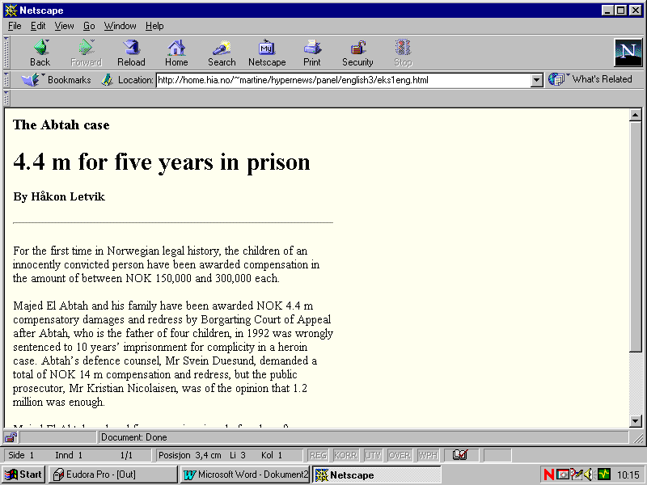

Demo 1. (Sreenshot)

Demo 1. The screenshot shows the first part of a traditional news story taken from the online version of one of the largets norwegian newspapers, Aftenposten. The story belongs to the journalistic field of crime & justice, concerning a person convicted as a drug criminal five years ago, now found innocent and receiving a certain amount of money as a compensation for the years behind bars. Viewed as a news text, it is quite long, quite complex, with a rather heterogenious mixture of text elements: facts from recent events, historical elements, pieces of interviews with involved persons, law scholars etc. It consists of a large number of extracts taken from different discourses, glued together to form a coherent narrative by the journalist, meeting the genre’s claim for drama, for logic and coherence, for moral.

Also, the genre’s principle of falling importance (most important bits first) means that the different topics, or source-discourses, are scattered around in the text, so that all the most important bits come in the start, the less important bits of the same discourse come later on etc.

All in all it’s a typical product of the journalistic process as it functions within the frames of linearity and conventional news-dramatizing.

In the next illustration (below) we see a version containing the same information - more or less - rewritten and structured as a hypertextual network of information.
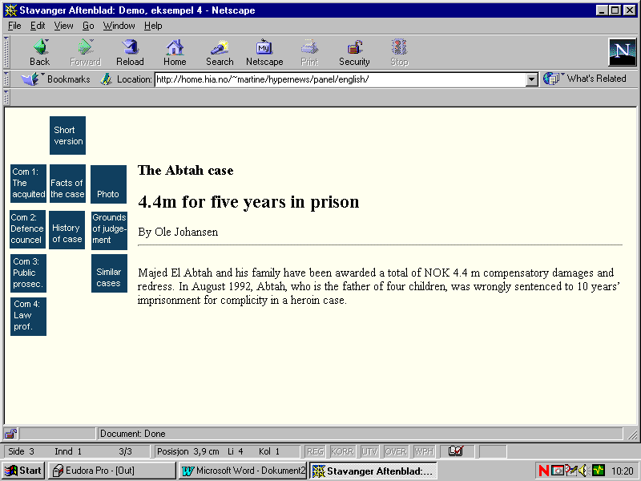

Demo 2. (Screenshot)

By use of frames, a map of all the different nodes stays permanently on the left side of the screen. This map shows the organizing principles of the construction. Here I have applied a horisontal axis going from the subjective to the objective. That means that a reader looking for a subjective perspective on the news event, can find the testimonies and versions of involved persons ( the victim, his lawyer, the state attorney etc) expert opinions etc. One node for each source. On this side one could also put journalistic comments on the case, highligthing certain aspects or viewpoints. In the middel one can find more hard core facts: the central events, a little background. On the right hand side one can find material belonging to the category «documentation»: grounds of the judgement, relevant laws, photos etc.

Prospective multimedia elements should be put where they belong according to this subjective-objective axis - which is, I will underline, but one chosen criteria for ordering the nodes. It is chosen because it reflects both certain journalistic values and certain aspects of the textmaterial.

A very short description of the news event is the first node one meets when accessing the system. To get to the other text elements, the reader is forced to make a choise and click on one of the buttons. The text elements in the nodes work as more or less indipendent texts, with a start and an ending, but they are not very long, and as for the content, they are very focused and homogeneuos.

rEFERENCES

Husserl, Edmund (1960) Cartesian Meditations: An Introduction to Phenomenology. Haag: Nijhoff

Peirce, Charles S. (1958-1960) Collected papers, edited by Charles Hartshorne and Paul Weiss.
Cambridge, Mass. : Harvard University Press

Rorty, Richard (1979) Philosophy and the mirror of nature
Princeton : Princeton University Press

Schütz, Alfred (1962) «On Multiple Realities» in Collected papers , Volume I: The Problem of Social Reality, edited by Maurice Natanson. Haag: Nijhoff

