A revised lecture on network arches in Chongqing in China 9th July 2012
Welcome to my lecture on network arches. I am very thankful that Director and Chairman Dr. Man-Chun Tang has arranged to let me give this lecture. He saw a picture of the very slim Brandanger Bridge in western Norway and invited me to give a lecture at T.Y. Lin in Chongqing.
欢迎诸位来听我的关于网状系杆拱的讲座。十分感谢邓博士安排我来做这次演讲。他看见过一张挪威西部的修长的Brandanger桥的照片，并邀请我来重庆的(T.Y.Lin 林同棪公司)做这次演讲。

Network arches are based on an idea that I got when I was working on my master’s thesis 57 years ago. It has been my main field of research ever since. By definition a network arch is an arch bridge with inclined hangers. Some of the hangers cross other hangers at least twice. (Tveit 1959,1966, 1980a,1981)
网状系杆拱主要是来源于57年前我在写硕士论文时候的一个概念。此后本人一直致力于研究网状系杆拱。网状系杆拱可以简单定义为一个具有倾斜吊杆的拱桥。其中一些吊杆之间至少有两次相互的交错。
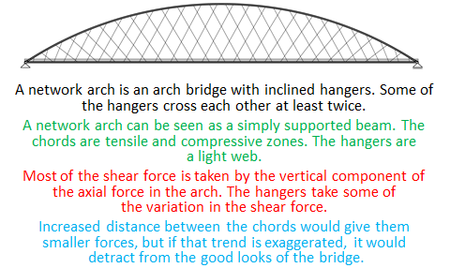
Fig. 1. A most competitive network arch. 图.1 一个最有竞争力的网状系杆拱

None of the references on the last page are given in Chinese.

网状系杆拱可以简单定义为一个具有倾斜吊杆的拱桥。其中一些吊杆之间至少有两次相互的交错。
一个网状系杆拱可以看做是一个简支梁。系杆是可以（伸缩/拉压）的区域。这些吊杆构成一个轻的网状结构。
大部分的（剪切力shear force）被拱的（轴向力 axial force）的垂直部分所承受。
矢高的增加会使得（轴向力 axial force）更小，但是如果这个距离太大，就会对桥的外表美观造成一些影响。

In one single lecture I obviously cannot tell you everything about network arches. In the first part of the lecture I will concentrate on good design of two-lane network arches. In the second part of my lecture I will present some supplementary information.
当然在一次讲座中我不可能对该结构讲的面面俱到。在讲座的最开始部分，我将着重讲述一个设计比较好的两车道网状系杆拱桥。在讲座的第二部分，我会讲述一些补充的信息。

Network arches have very little bending in the chords. The arches are well supported by the hangers. Thus they can take high buckling stresses.
网状系杆拱结构系杆的弯矩很小。主拱被吊杆很好的支撑。因此，他们可以承受较高的屈曲应力。

Two-lane network arches for road bridges are very competitive, and not too difficult to design. Longitudinal prestressed concrete ties are assumed.
对于公路桥梁来说两车道网状系杆拱非常具有竞争力，并且设计起来并不困难。这里我们假定采用纵向预应力混凝土系杆。
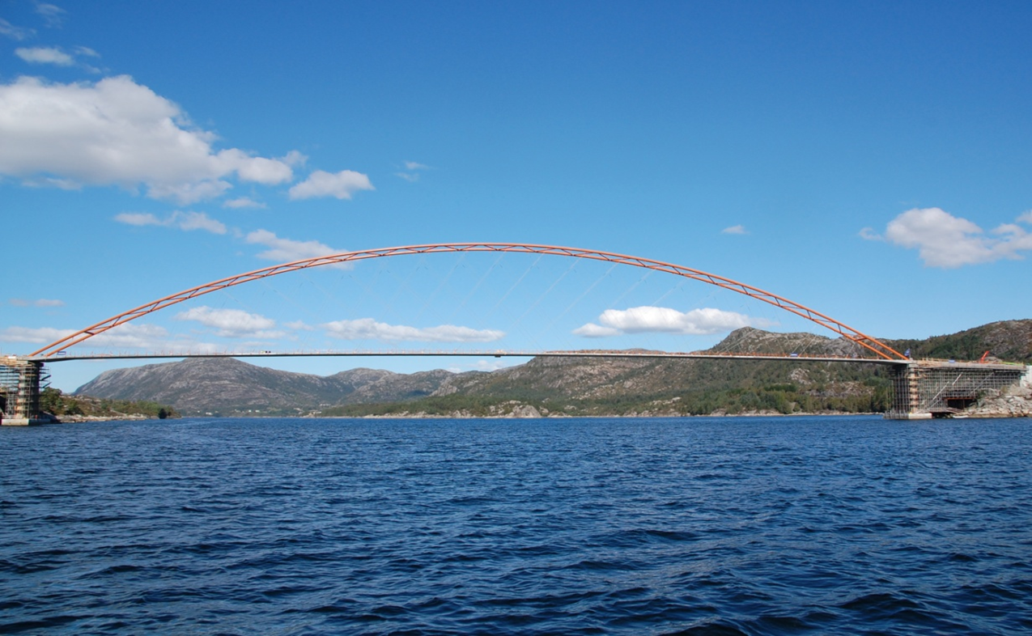
Fig. 2. The Brandanger Bridge in western Norway has a main span of 220m. It was opened in 2010. (Tveit 2004a, 2004b, 2004c)
图.2 挪威西部的Brandanger桥具有220m的主跨部分。2010年建成通车。

The final design of the Brandanger Bridge was done by the firm Aas-Jakobsen in Oslo, Norway.
这座桥的最终设计是由挪威奥斯陆的Aas-Jakobsen公司完成的。

The bridge leads to some islands with about 400 inhabitants. The lane is only 5m wide. That corresponds to the width of most roads on the islands.
该桥连接了一些大约有400人居住的小岛。车行道宽度只有大约5m。这与岛上的大部分道路宽度相当。

The arch is part of a circle. I would have liked to have a bigger rise of the arch. Because that would have looked better and would have saved some money.
该桥的主拱是圆的一部分。我更希望可以有一个更高的主拱。这样会使得桥看起来更美观并且能够节约造价。
Fig. 3. Some dimensions of the Brandanger Bridge
图.3 Brandander桥的一些尺寸

Fig 3 gives some dimensions of the main span of the Brandanger Bridge. You can see that the height of the tie is 400 mm. The outside diameter of the steel tubes in the arches is 711 mm.
图3显示了Brandanger桥主跨的一些尺寸。从图中可得知系杆高400mm。拱钢管外直径711mm。

If we define the slenderness of an arch bridge as the span divided by the sum of the heights of the chords, then the slenderness of the Brandanger Bridge is nearly 200.
如果将拱桥的（长细/跨高比/柔度 slenderness）定义为跨度除以总的系杆高度，那么Brandanger 桥的（长细/跨高比/柔度 slenderness）大约为200。

The Brandanger Bridge might remain the world’s most slender arch bridge for many years to come. This is because bridges for long spans will usually have more lanes and thicker chords.
在未来的数年内，Brandanger桥可能会依然是世界上最（细长/柔 slender）的桥。这主要是因为长跨度的桥通常会有更多的车道和更粗的系杆。(Tveit 2004a, 2004b, 2004c)
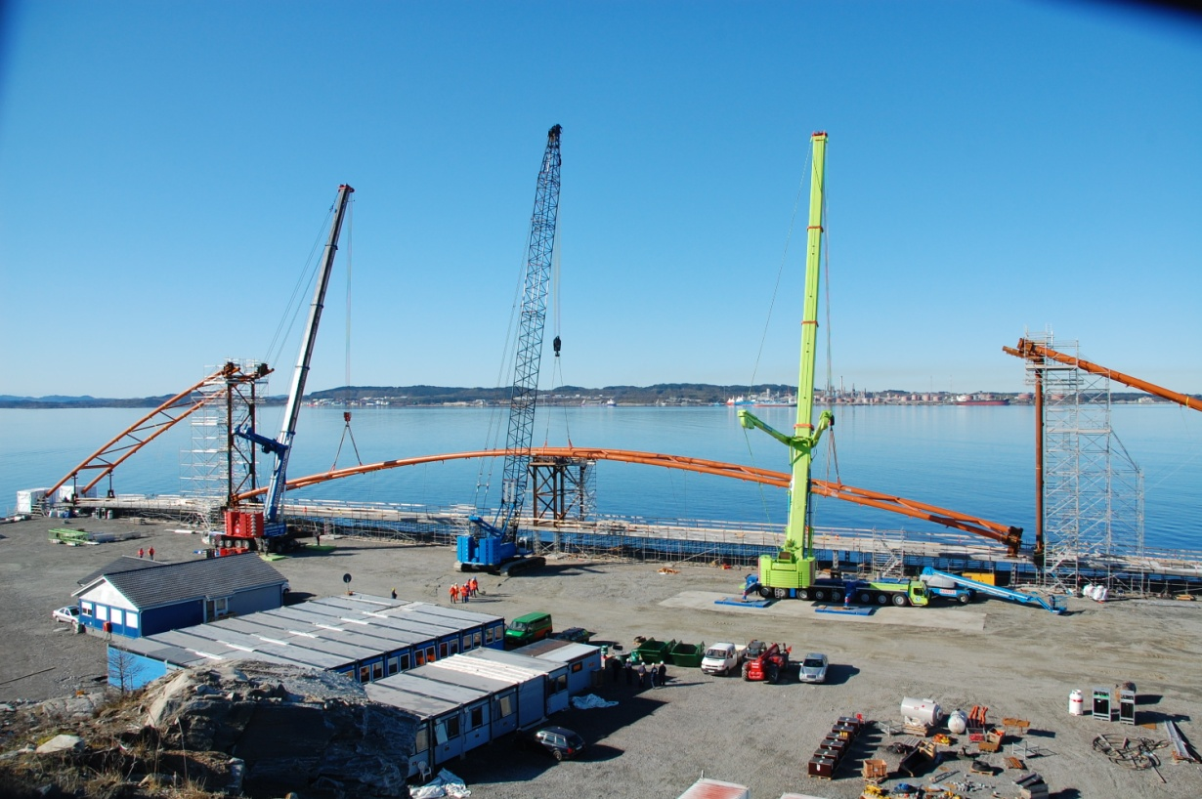
Fig. 4. The lifting of the middle of the arch
图.4 主拱中间部分的吊装

The main span of the Brandanger Bridge was built on a plain where rocks had been taken out for covering pipelines in the North Sea.
Brandanger桥的主跨在北海的一片平地上建造，这个地方的原有的岩石被用去覆盖海中的输油管线。

First the tie was cast and prestressed. In fig. 4 the middle of the arch is lifted into place by three mobile cranes.
首先系杆被浇筑并施加预应力。如图4，主拱的中间部分由三辆吊车升起吊装就位。
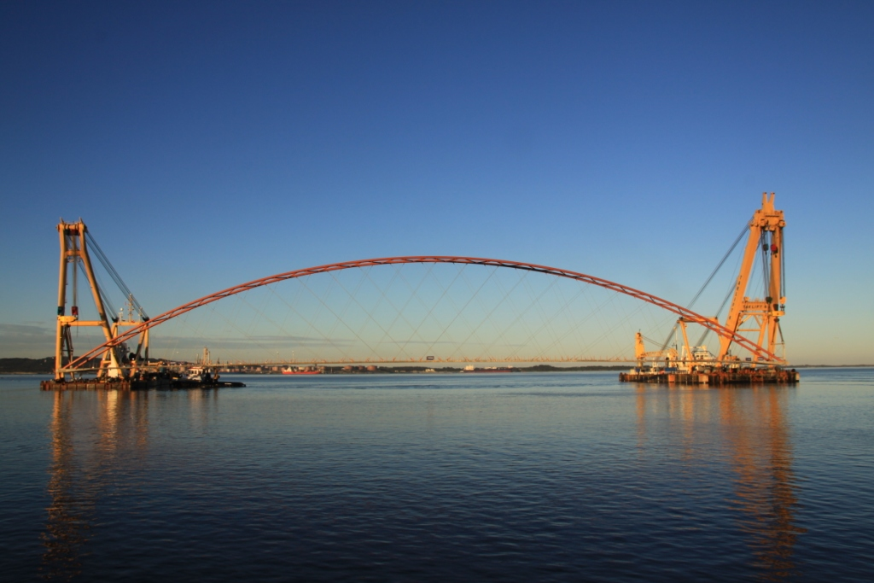
Fig. 5.
Fig. 5. Lifting of the main span of the Brandanger Bridge
图.5 Brandanger桥主跨部分的吊装

The main span weighed 1862 tonnes. It was lifted by two Dutch floating cranes.
主跨重1862吨。由两艘荷兰的起重船将主跨吊装就位。
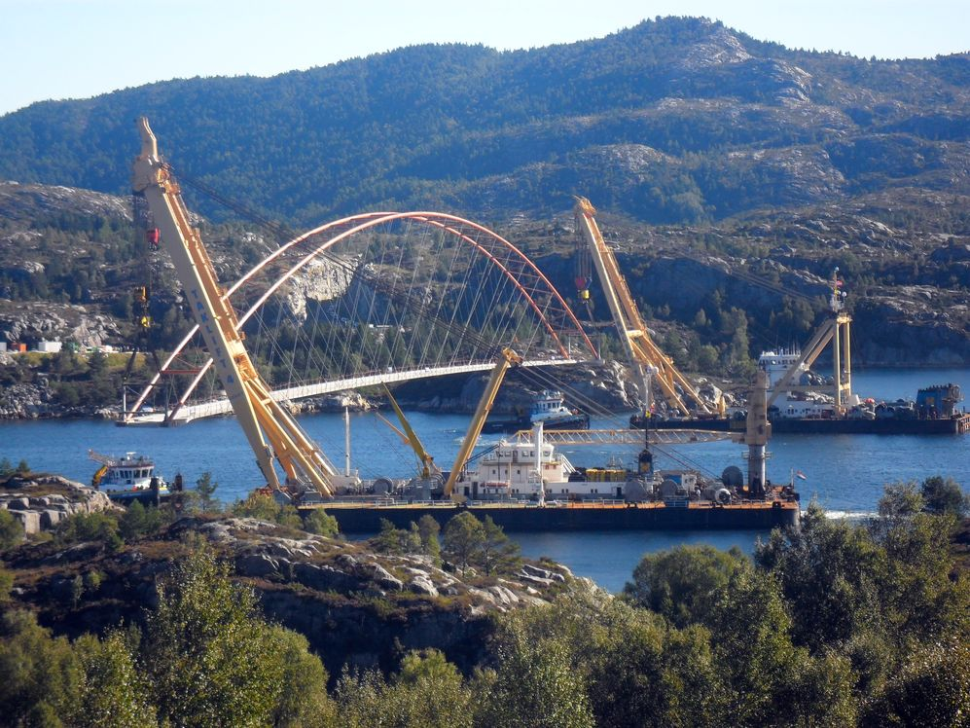
Fig. 6 It was transported 5 km to the bridge site.
图.6 从预制工地到桥位处约5km
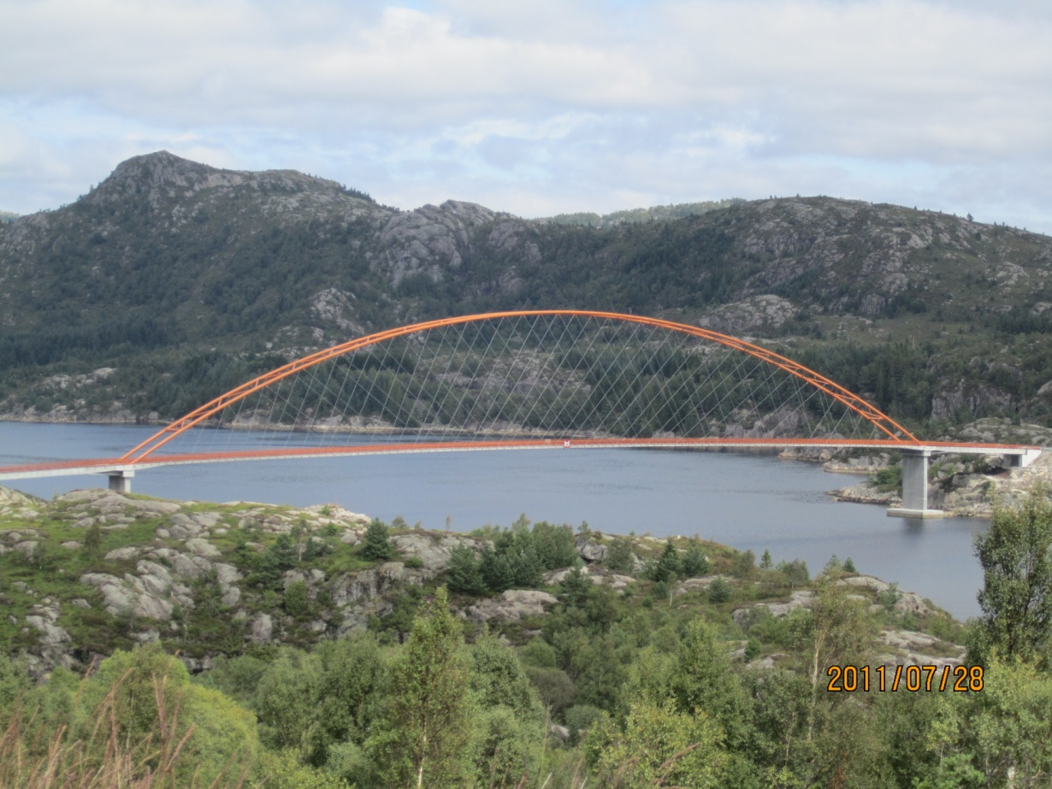

Fig. 7. The finished Brandanger Bridge.(Larsen & Jakobsen 2011)
图.7 竣工后的Brandanger桥

Try to imagine how slim the bridge would have looked if the arches had been right behind each other.
请试想一下如果从桥两边的主拱重叠的角度看过去，这座桥是有多么的纤细。
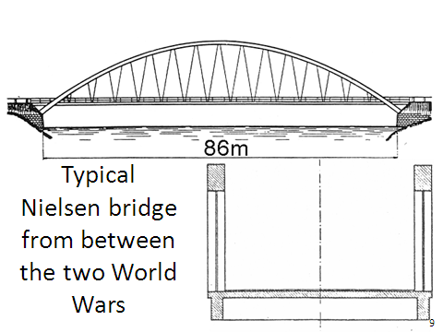
Fig. 8. The Nielsen bridges are the forerunners of the network arch.
图.8 Nielsen桥是网状系杆拱的前身 (Nielsen1929, 1932, 1936, )

Around 60 Nielsen bridges were built in Sweden between the two World Wars. (Ostenfeld 1976).
两次大战期间瑞典修建了大约60座Nielsen桥。

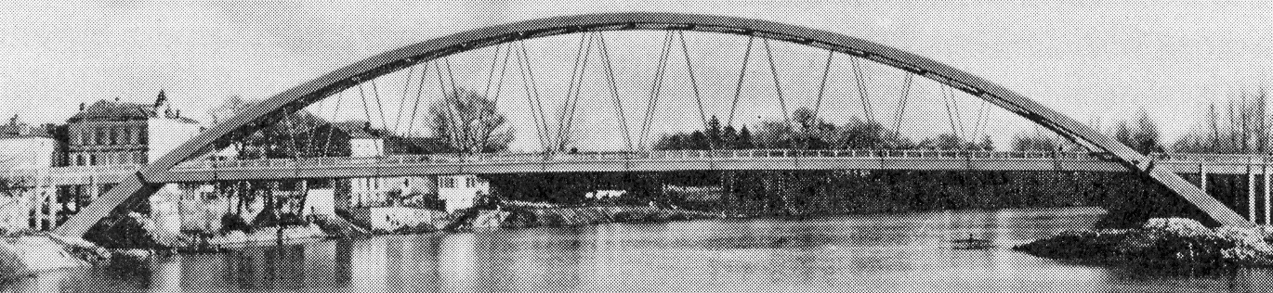
Fig. 9. The longest Nielsen Bridge. Castelmoron 1933. Span 145 m.
图.9 最长的Nielsen桥，Castelmoron 1933，跨度145m

The hangers were steel rods. For loads on one side of the span many hangers relax.
吊杆由钢条组成。当载荷位于桥跨的一侧时，许多吊杆会放松。

In the lifetime of the Nielsen Bridges there has been a great increase in the traffic loads, but breaking of hangers has not been a problem.
在Nielsen桥的使用过程中，交通运输量有了显著增加，但是从未有吊杆断裂的问题出现过。

In his PhD thesis in 1929 O. F. Nielsen explained how his bridges could be calculated.
在1929年 O. F. Nielsen的博士论文中结识了该如何计算尼尔森拱桥。
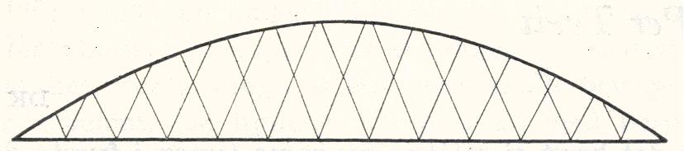
Fig. 10. Drawing from a patent document. (Nielsen 1926)
图.10 专利文档中的图

Nielsen never crossed the hangers of his bridges, but in a patent document in 1926 he showed crossing hangers.
Nielsen从没让他的桥上的系杆交错，但是在1926年的一份专利文当中，他展示了交错的系杆。

Sometimes the arch of the Nielsen bridges was cast in the spring from a scaffold resting on the ice. When the ice broke up in the spring, the casting of the tie was supported by the arch. (Ostenfeld 1976)
Nielsen桥的拱有时在春天冰面上的脚手架上浇筑。当春天融冰的时候，系杆的浇筑由拱来支撑。

Today we have stronger materials and bigger traffic loads. That makes it advantageous to let some hangers cross each other at least twice.
如今我们有高强度的材料以及更大的车流量。这就使得吊杆之间相互交错至少两次的优势得以发挥。
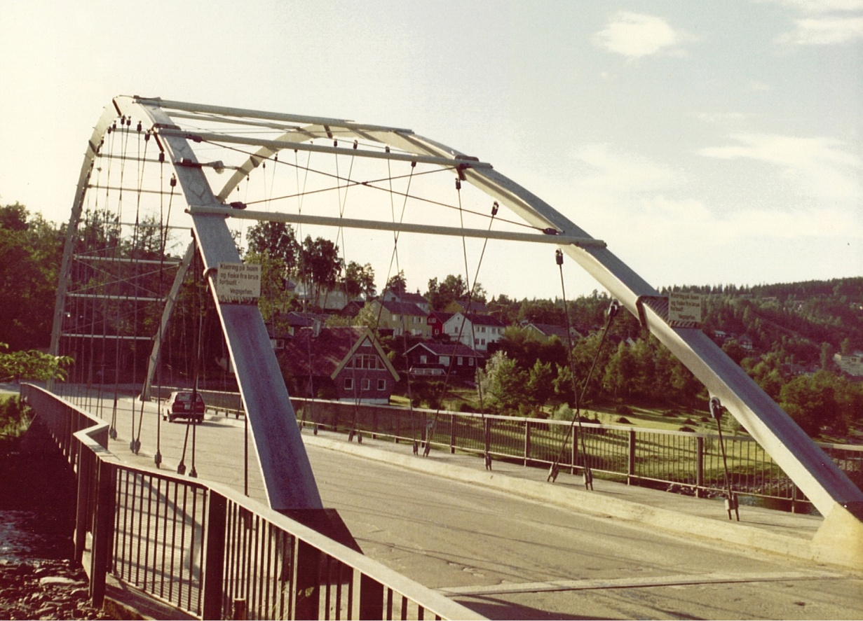
Fig. 11 The network arch at Steinkjer. Opened 1963. (Tveit 1980b)
图.11 Steinkjer的网状系杆拱桥。1963年建成。

After 8 years of study, designing and building, my first network arch was opened at Steinkjer in Norway in 1963. It is a mistake that there are no railings between the road and the hangers. Still the bridge is in good shape after 49 years.
历经8年的研究，设计和施工后，我的第一个网状系杆拱桥于1963年在挪威的Steinkjer 建成投入使用。这座桥的一处失误是车道与吊杆之间没有防护措施。尽管如此，49年后这座桥看起来仍然不错。

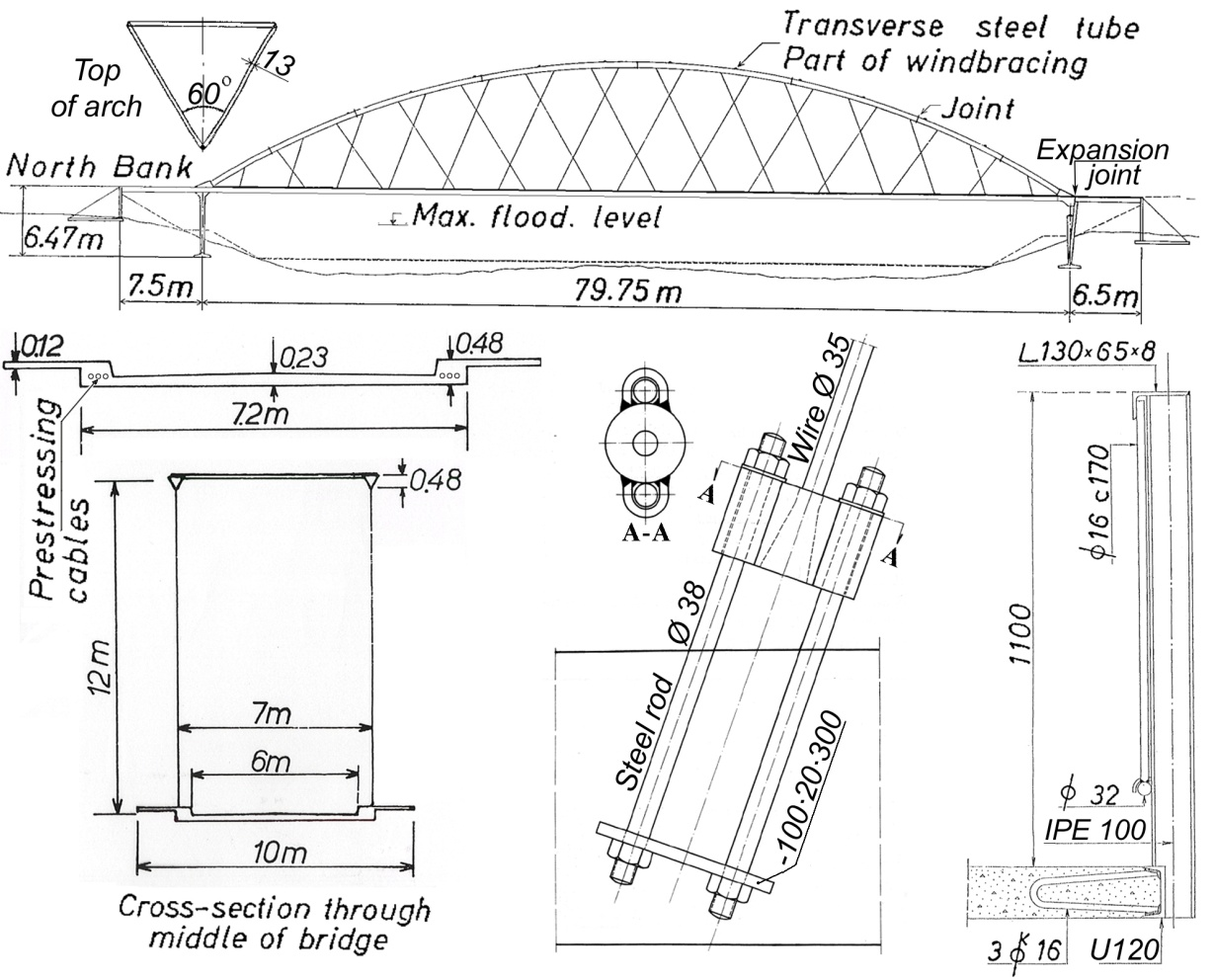
Fig. 12. Structural details for the Steinkjer Network arch.
图.12 挪威Steinkjer拱桥的结构详情 (Tveit 1959, 1664, 1966, 1987)

Here are some structural details of the Steinkjer network arch. The arches are triangular. The length of the hangers can be adjusted. The railings are fastened to the outside of the concrete slab under the footpaths. Prestressing cables take the tension in the tie.

这里有一些关于Steinkjer网状系杆拱桥的结构详述。主拱断面是三角形的。吊杆的长度可以调节。护栏固定在人行道下的混凝土板的外侧。预应力线缆承担系杆中的拉力。

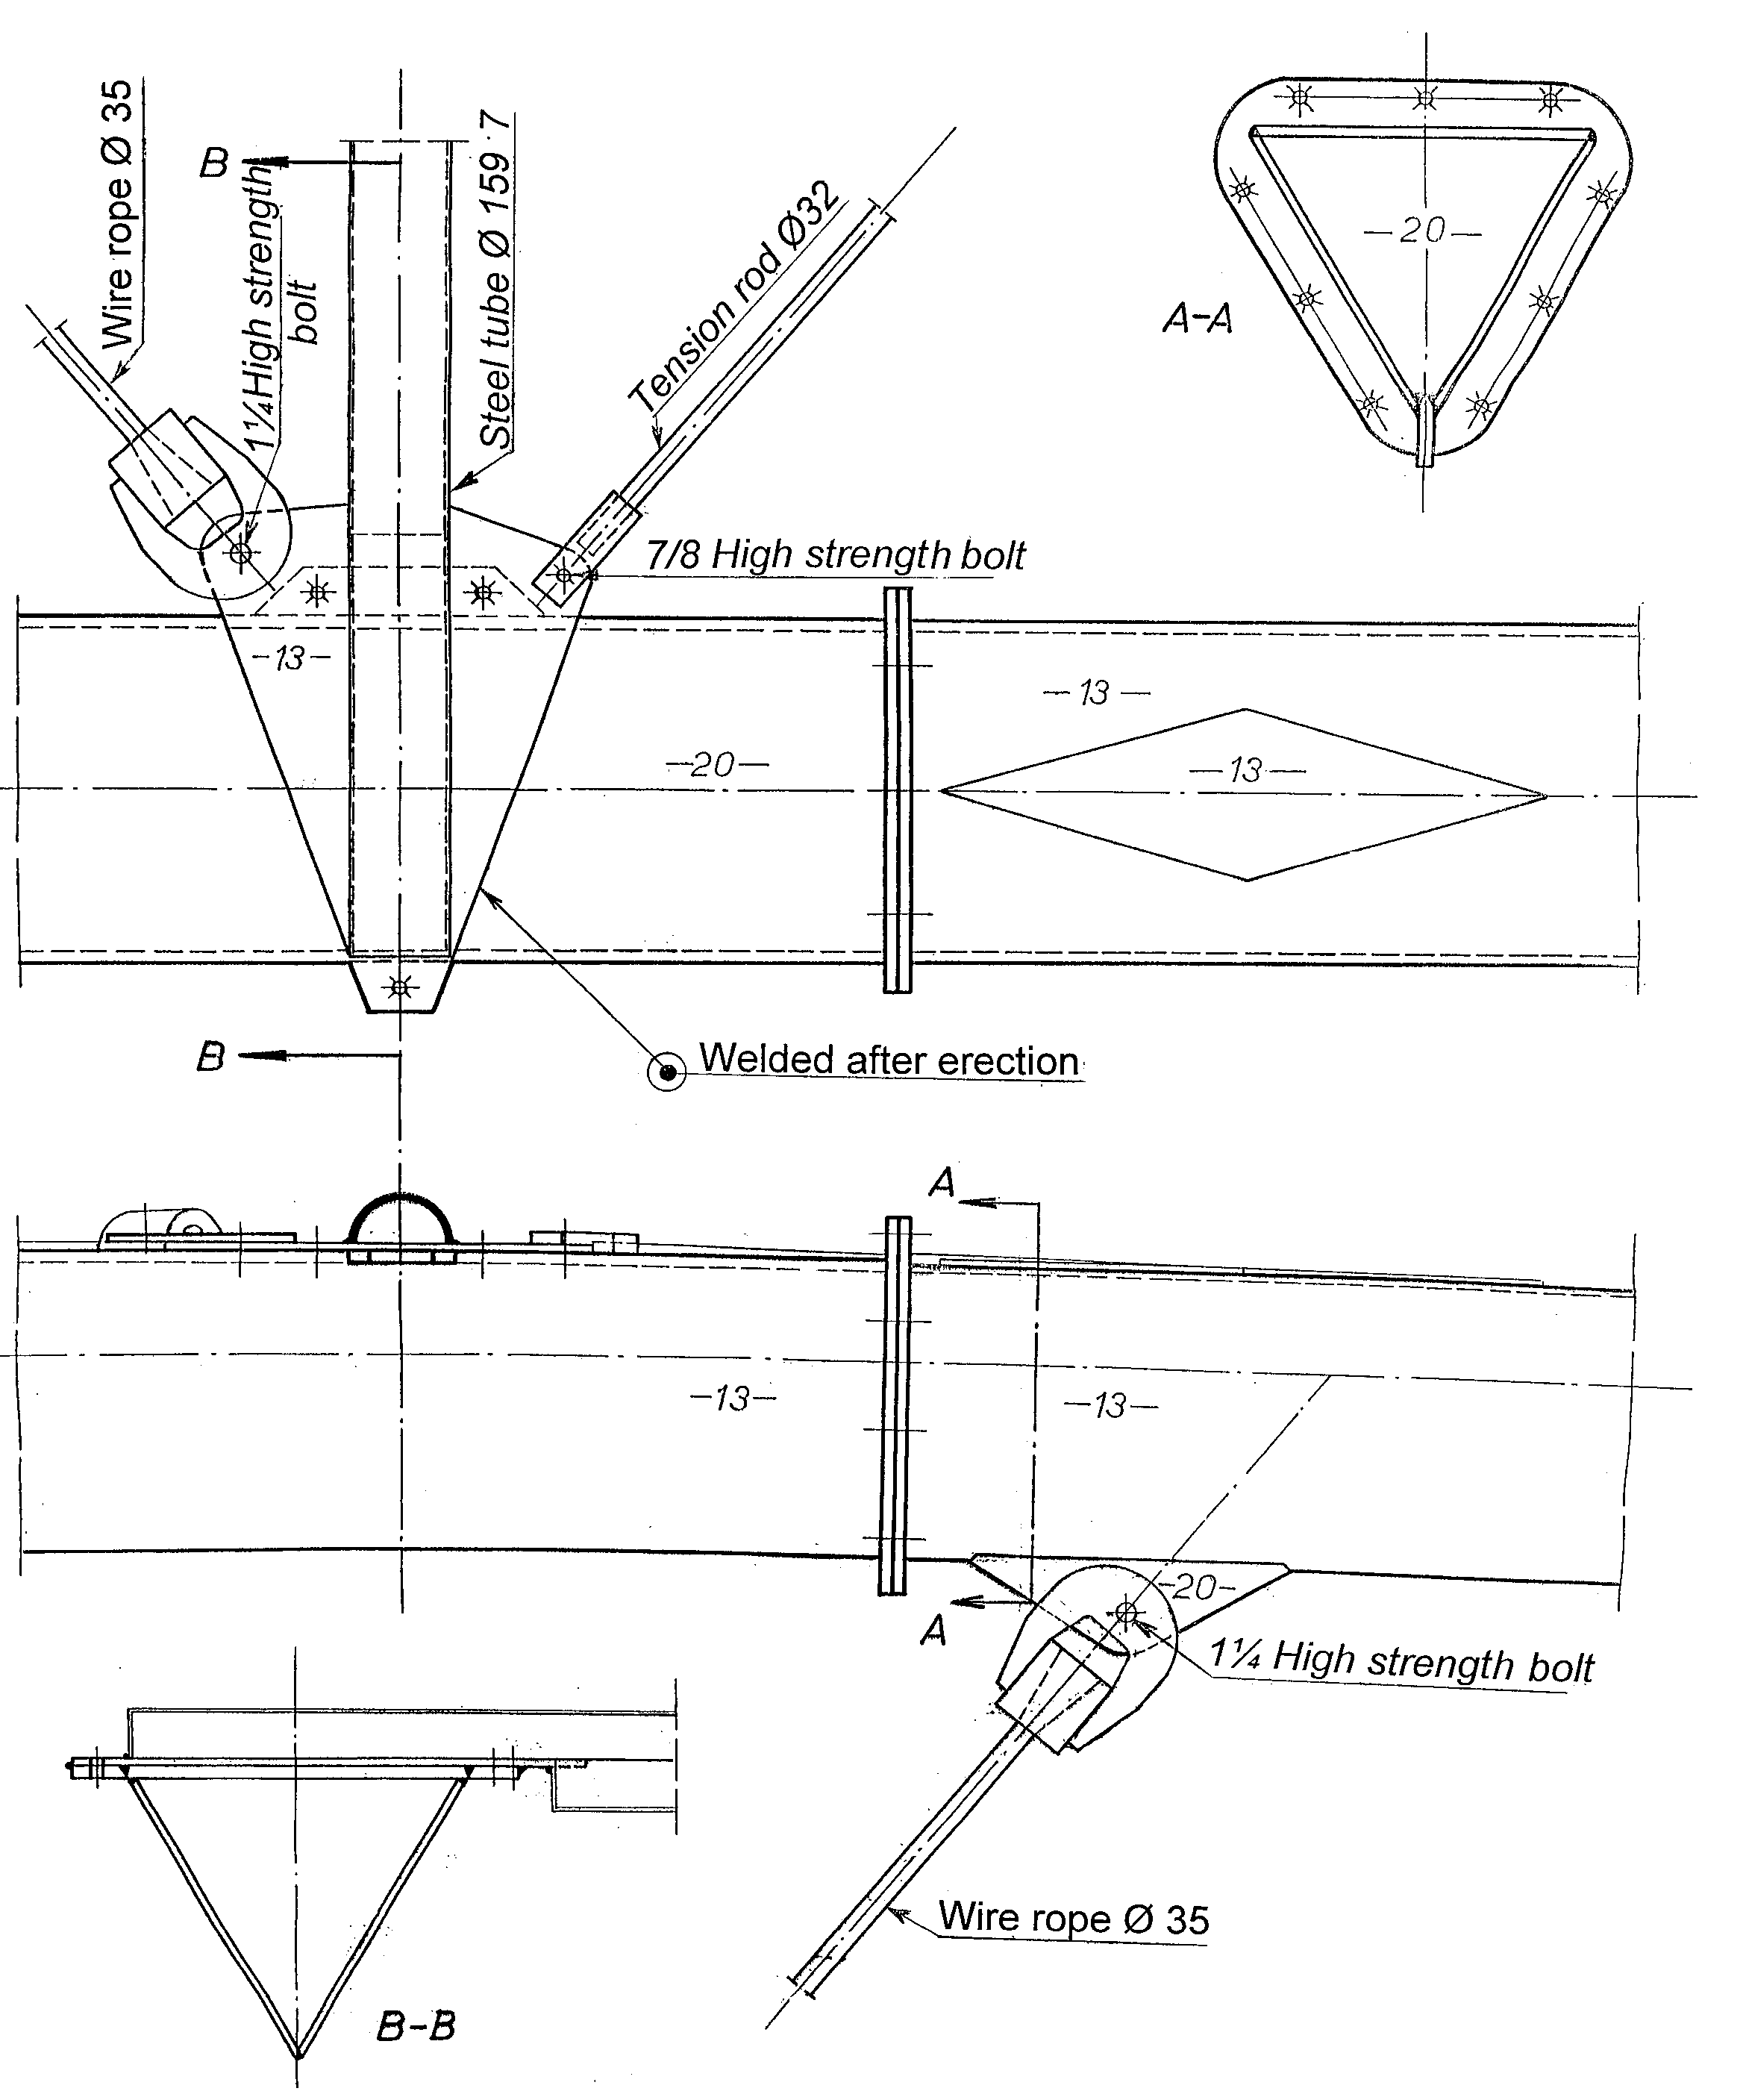
Fig. 13. Details in the arch of the Steinkjer network arch
图.13 Steinkjer网状系杆拱桥主拱部分的细节

Fig. 13 shows structural details around the second transverse tube in the wind bracing. The joints in the arches are simple flanges.
Most diagonals in the wind bracing are steel rods, but the diagonals nearest to the ends of the arches are wire ropes of the same kind as used in the hangers.
图13中描述了（风撑wind bracing）中第二根横向钢管的构造细节。拱的连接处使用简单的（凸缘联轴节flanges）。（风撑wind bracing）中的大多数（斜向吊杆diagonals）采用钢条，但是靠近拱尾部的的（斜向吊杆diagonals）采用了和吊杆一样的钢丝索材质。

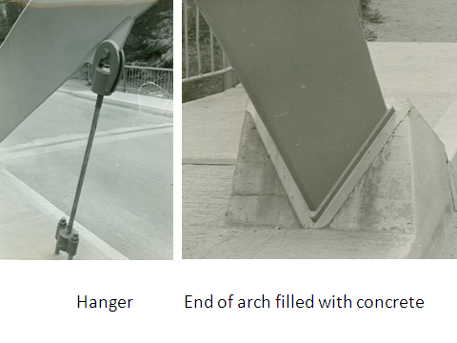
Fig. 14. Hanger and end of an arch
图.14 吊杆和主拱的端部

Fig. 14 shows the shortest hanger and the end of an arch. It is filled with concrete to increase its ability to withstand traffic colliding with it.
图. 14中显示了最短的吊杆和主拱的端部。混凝土的灌注增加了其抗击车辆碰撞的能力。
(Tveit 1980a, 1984, 1984a, 1987, 1992)

Influence lines for the network arch at Steinkjer
The slope of the steepest hanger is 74.4°. The difference in the slope between two adjoining hangers is 1.8°.
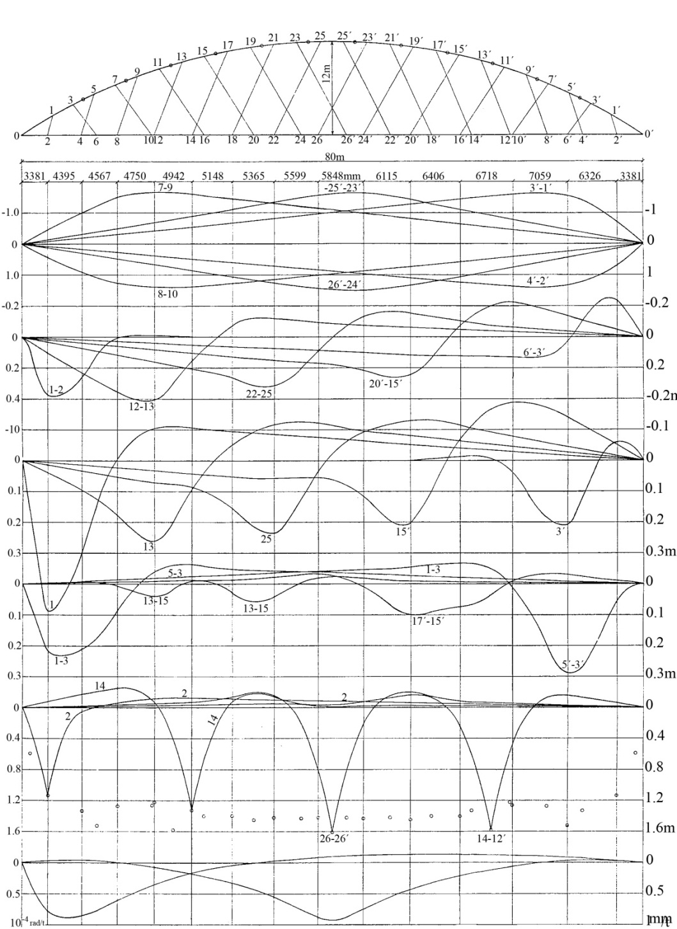

Compression in arch

Tension in tie

Force in hangers

Bending moments at nodal
points in arch

Bending points in the middle of members in arch

Bending moments in tie

Rotation at the end of the tie
Deflection of tie at the
middle of the span
Fig. 15. Here are some influence lines for the network arch at Steinkjer. You can see that the bending moments in the tie do not change much except near the end of the span. (Tveit 1992, 1999a, 2010)
图. 15一些Steinkjer网状系杆拱桥的影响线。从中可看到，除了桥跨端位置外，其他地方的（系杆弯矩bending moments in the tie）变化都比较小。

The hanger forces are very even. So are the axial forces in the chords, but they increase a little near the ends of the span.
吊杆内力很均等。系杆的轴向力同样如此，但是在桥跨端处，这些力有一些增大。

Normally the arch should have a nearly constant curvature, but the curvature might be a bit smaller near the ends of the arches.
拱曲率应当接近常数， 但是拱末端的曲率可能会稍微小一点。
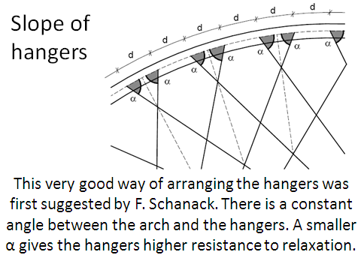
Fig. 16. Slope of hangers.
图.16吊杆的斜度

There should be a constant angle between the arch and the hangers. This is a very good way of arranging the hangers. It was first published by Frank Schanack and Benjamin Brunn. Schanack did his doctorate on network arches in Spain in 2008. Now he is a professor in Chile.
主拱和吊杆之间应是一个常数角度。这样比较有利于吊杆的排列布置。这个建议由Frank Schanack 和 Benjamin Brunn首次提出。Frank于2008年在西班牙完成他的关于网状系杆拱桥的博士工作。现在他是智利的一名教授。
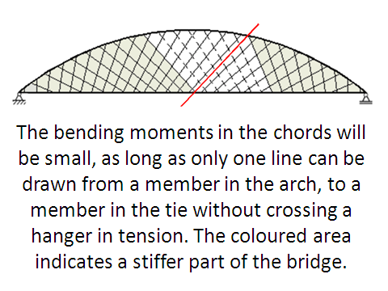
Fig. 17. Large angles between arch and hangers make it more likely that hangers relax. If many hangers relax, the bending moments in the chords increase.
图.17 主拱和吊杆之间角度的增大更可能使吊杆放松。如果许多吊杆放松，系杆中的弯矩就会增大。

These bending moments will be insignificant as long as only one line (or none) can be drawn from a member in the arch to a member in the tie without crossing a hanger in tension. That is because the grey parts of the bridge that are tied to each other by hangers in tension are rather stiff.
我们可以画连接从拱到系杆的直线，当仅有一条线（或者没有）未穿过受拉的吊杆时，弯矩就会非常小。这是因为桥梁灰色的部分是通过受拉的吊杆互相连接，刚度较大。

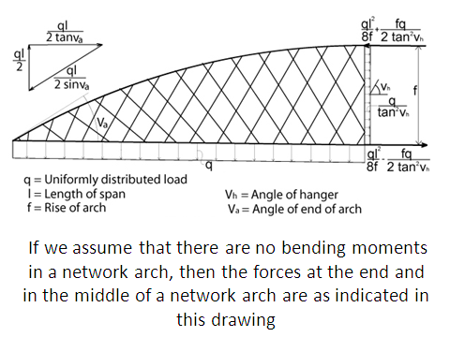
Fig. 18. Forces in the middle and the end of a network arch
图.18 一座网状系杆拱桥中部和端部的力

If we assume that there are no bending moments in a network arch, then the forces at the end and in the middle of a network arch are as indicated in this drawing.
我们假设一座网状系杆拱桥没有弯矩，那么这张图显示了网状系杆拱桥中部和端部的力。

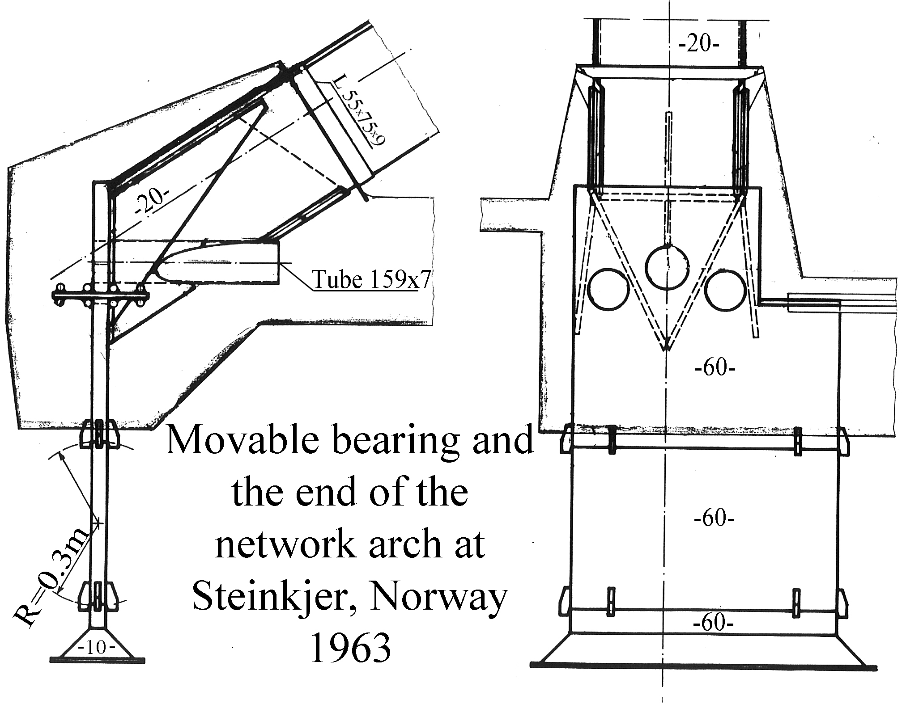

Fig. 19. This slide shows the movable bearing and the end of the network arch at Steinkjer. The big end plate was examined for lamination.
图.19 这一张是Steinkjer网状系杆拱桥的（滑动支座movable bearing）和（端头end）构造示意图。大的（端部板end plate）要经过检查确保没有（层压lamination）。

Fig. 20
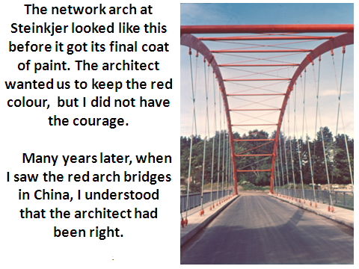
图.20 Steinkjer拱桥在最后的粉刷前是这个样子的。建筑师希望我们保持红色外观，但是我当时没有如此大的勇气。后来，当我在中国看到红色的拱桥时，才明白建筑师是对的。
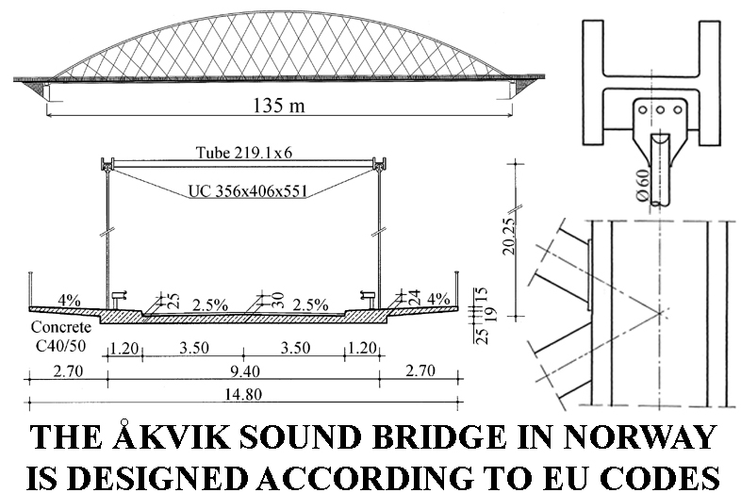
Fig. 21. This is a network arch from a 300-page master’s thesis by (Teich &. Wendelin. 2001). Their calculations can be found on my homepage. http://home.uia.no/pert
图.21 这是(Teich &. Wendelin. 2001)一篇300页硕士论文中的一座网状系杆拱桥。在我的主页中可以找到他们的有关计算。http://home.uia.no/pert

Teich completed his doctorate on network arches this year. (Teich 2012). Please note that the arches are universal columns with a yield stress of 430 N/mm². These profiles can be cold bent at the steel works. Two ways of fastening the windbracing to the arches are shown.
Teich今年完成了他关于网状系杆拱桥的博士论文。请注意这些拱桥使用的标准钢构件屈服应力是430 N/mm²。这些组件可以在钢厂冷弯加工成型。将风撑固定到主拱上有两种方法可以参考。

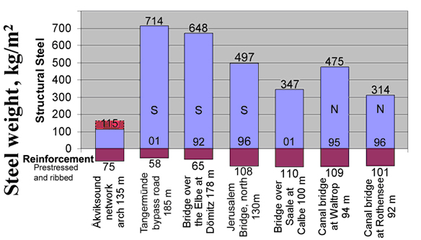
Fig. 22. Here the steel weight of the Åkvik Sound Bridge is compared to the steel weight of German tied arch bridges with vertical hangers.
图.22 这是Åkvik Sound网状系杆拱桥与德国的几座竖直吊杆拱桥在用钢重量上的对比。

S means that the arches are sloped towards each other.
N means that there is no wind bracing. Steel in a temporary tie would be 51 kg/m².
“S”表示两个逐渐靠近的拱坡。“N”表示没有风撑。Åkvik Sound桥的临时低系杆用钢两大约为51 kg/m²。

All the bridges have been designed using roughly the same codes.
所有的桥梁均采用相同的规范设计。
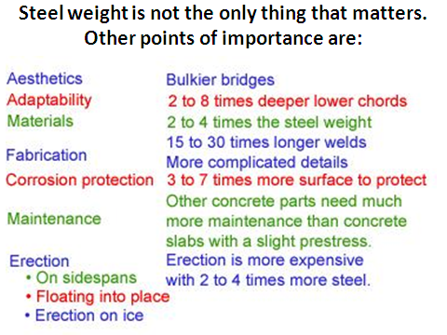
Fig. 23. Steel weight is not the only thing that matters.
图.23 用钢量并不是我们唯一关心的。竖直吊杆拱桥体积更大。他们有2到8倍深的系杆。15到30倍长的焊缝深度。3到7倍多的需要养护的刚表面。 其他的混凝土部分需要比轻微预应力混凝土板更多维护。架设成本更高，因为需要2到4倍多的钢材。

Part of the great saving of steel is because higher steel strengths have been assumed. Furthermore the transverse span between the arches is much smaller in the network arches. (Graße et al 2007)
大量节省钢材的一部分原因是我们假设采用更高强度的钢材。进一步讲，网状系杆拱的拱之间的横向跨度更小。
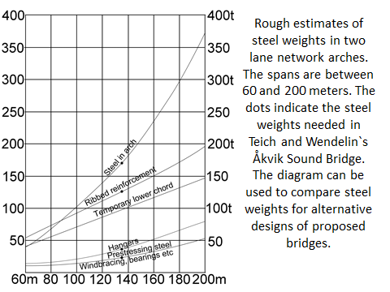
Fig. 23. This diagram gives a rough estimate of steel weight in two-lane network arches. The spans are between 60 and 200 m.
图.23 这幅图给出了两车道网状系杆拱桥的大约估计用钢重量。跨度在60到200m之间。

The dots indicate the steel weights needed in Teich and Wendelin`s Åkvik Sound Bridge.
圆点表示Teich and Wendelin的Åkvik Sound桥所需要的用钢重量。

The diagram can be used to compare steel weights for alternative designs of proposed bridges.
对一座需要建设的桥，这张图可以用于对比各种备选设计方案的用钢重量。
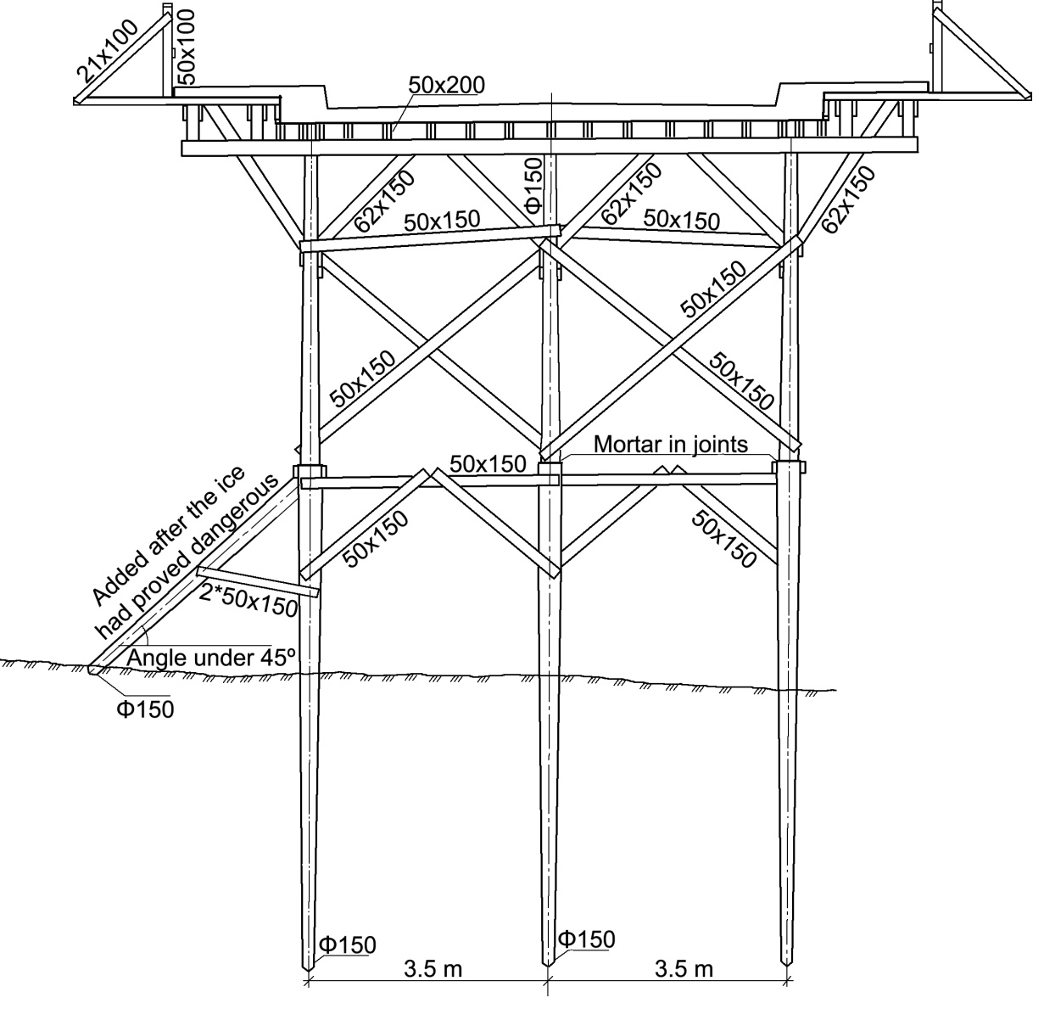
Fig. 24. The scaffolding for the network arch at Steinkjer is shown in this slide. After the concrete tie was cast, the arch was erected. Then the hangers were installed and tensioned till they carried the tie. Then the wooden scaffolding was removed.
图.24 图中描绘了Steinkjer网状系杆拱桥的脚手架构造。在浇筑了混凝土系杆之后，架设主拱。接着安装并张拉吊杆直到他们触及系杆。之后移除木制的脚手架。

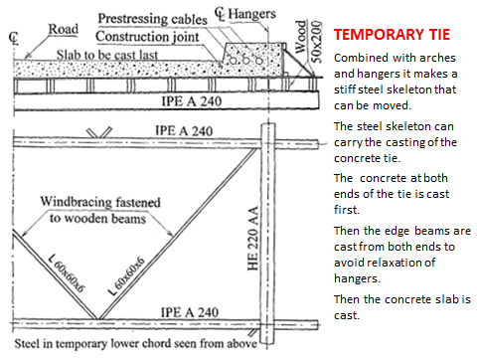
Fig. 25. Many promising methods of erection can use this temporary tie.
图.25 许多好的架设方法中用到这种临时系杆

与主拱和吊杆结合后，临时系杆可以构造出一个可移动的坚硬钢制骨架。他也可以承担混凝土系杆的浇筑。首先浇筑桥跨两端的混凝土。接着从两端开始浇筑边梁，这样做是为了防止吊杆放松。然后浇筑混凝土板。
(Tveit 2009, 2009b, 2010, 2011)
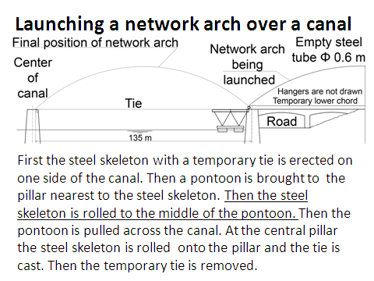
Fig. 26. Launching a network arch over a canal.
图.26 在河道上架设网状系杆拱桥。临时系杆可以用于在河道上架设网状系杆拱桥。 首先在河道的一侧架起带有临时系杆的钢骨架。然后将钢骨架移动到浮船中间。接着将浮船牵引到河道中。然后将钢骨架移动到桥墩上并浇筑系杆。最后拆除临时系杆，这个拆下的临时系杆可以再次用于其他的网状系杆拱桥。(Geißler et al 2008)

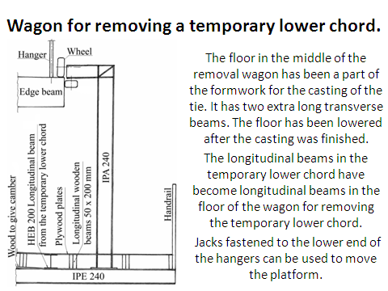

Fig. 27. ©This drawing shows a wagon for removing the formwork and the temporary tie.
图.27 © 这张图描述了移除框架和临时系杆的车辆装置。车辆中板已经被用于浇筑混凝土系杆。它具有两个很长的横梁。

当浇筑完成之后中板被下移。临时系杆的纵梁变成了中板的纵梁，中板用于移除临时系杆。

固定于吊杆的低处末端的（千斤顶jacks）可以用来移动平台。

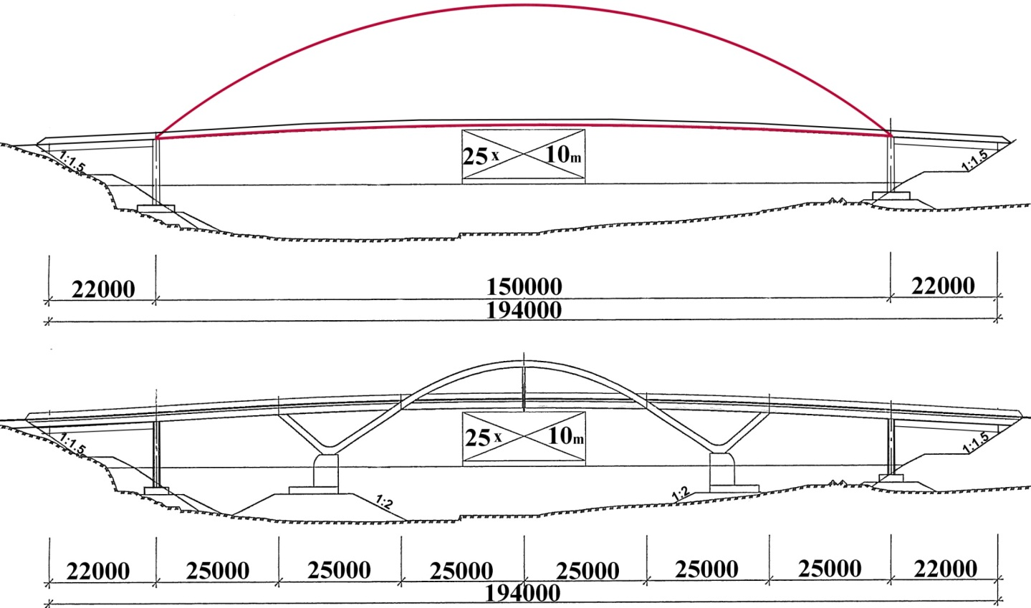
Fig. 28. Two bridge alternatives for a fjord in western Norway
图.28 位于挪威西部峡湾的桥的两个备选方案

In a play by the Norwegian playwright Henrik Ibsen a poet says: “The unborn poems are often the most beautiful.”
挪威戏剧家易卜生的剧本中的一首诗中写到：“未创作出的诗往往是最美丽的”

That is how I feel about the more slender of the two bridges in fig. 28.
It might be built on the northern shore of the longest Norwegian fjord.
这也是我对图28中两座更修长的桥的感受。它或许可以建在位于北部海岸的挪威最长的峡湾上。

Of course the network arch would look less slim if the arches were not right behind each other.
当然如果两个拱没有恰好重叠的话，网状系杆拱桥看起来并不是那么纤细。
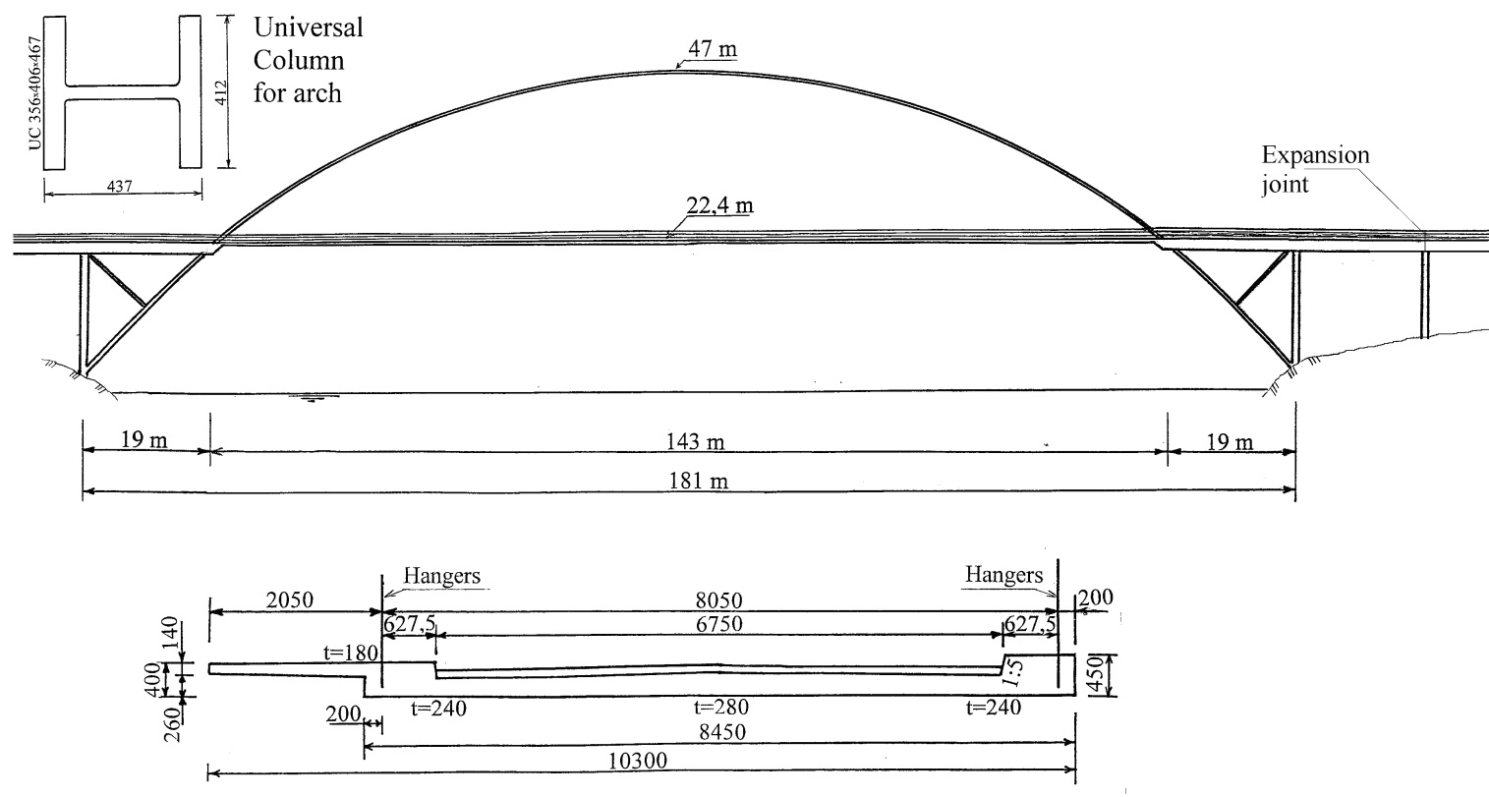

Fig. 29. A suggested network arch across a fjord in western Norway.
图.29 跨越挪威西部一个峡湾的网状系杆拱桥建议方案

This network arch could have been built across a fjord in western Norway. There, ships are few and far between. Thus parts of the arches can be near to the water level. (Tveit 2001, 2002, 2002a)
这个网状系杆拱桥本可能修建在挪威西部的一个峡湾之上。那里船只稀少并相距较远。因此拱桥的一部分可以接近水面。

The steel skeleton consisting of arches, hangers and a temporary lower chord, could be assembled on one side of the span to be lifted across the fjord.
有主拱，吊杆和临时系杆构成的钢骨架，可以在桥跨的一侧组装完成等待吊装跨越峡湾。

The parts of the arches that are below the lane can be floated in place. The steel skeleton could also be assembled far from the bridge and be floated to the bridge to be lifted in place. Then the concrete tie could be cast.
车到下方的主拱桥部分可以浮运到位。钢架也可以在其他地方组装并浮云到吊装的位置。之后可以浇灌混凝土。
Now I would like to say something about the breaking of hangers. If the hangers are steel rods that fail in fatigue, that is not likely to be serious. The other hangers are not likely to fail at the same time. Thus we are likely to have ample time to replace the hanger.
现在我想说一点关于吊杆断裂的问题。如果吊杆是钢条因疲劳断裂，问题貌似并不严重。其余的吊杆可能不会在同一时间断裂。因此我们有充裕的时间去更换吊杆。

If two hangers that are next to each other at the lane fails, then they are far apart at the arch. Thus the bridge will not fail.
如果车行道上相邻的两个吊杆断裂，这两根吊杆在拱上相距会很远。这样的话桥梁不会垮塌。

Learned friends have told me that the network arch is a robust structure. (Zoli & Woodward 2005)
一些学识渊博的朋友告诉我网状系杆拱是非常健壮的结构。

In wide network arches creep and shrinkage might make it difficult to control the deflection in plates spanning between the edge beams.
在一个宽的网状系杆拱中，收缩徐变问题使得控制两个边梁之间的（桥面板plates spanning）的挠度变形很困难。

If problems arise, transverse reinforced polymer ropes can be put under the concrete slab. The size of wedges between the ropes and the concrete plate can be used to control the deflection.
如果这个问题出现，可以再混凝土平板下安装横向的加强聚合缆绳。缆绳和混凝土平板中间的楔形块的尺寸可以用来控制挠度变形。

Transversally prestressed plates between the edge beams will have a tendency to move upwards in the middle. That can be counteracted by using some prestressing rods where the stress can be adjusted in the lifetime of the bridge.
边梁中间的横向预应力平面会出现反拱。可以利用一些可调节压力的预应力钢绞线来消除返拱桥。

Many countries that are developing fast can expect a great increase in traffic. Then it might be a good idea to build network arches for the present traffic, but have plans ready for a second network arch when the traffic demands it.
许多迅速发展的国家将会有大量增加的交通。如此一来根据现有的交通量建立网状系杆拱桥，同时为考虑到之后更大的交通需求量，做好第二座网状系杆拱桥的设计准备是一个很好的思路。
Sometimes the roads have a strip of grass between lanes of traffic. Then two slim parallel network arches can be used to cross a river or fjord.
有时候道路非同向车道之间会有一些绿地保护带。在河流或峡湾上架设两座平行的网状系杆拱桥可以达到这种效果。
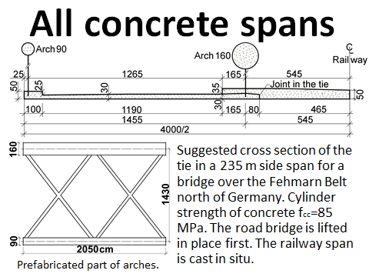
Fig. 30. The Nielsen bridges were made of concrete. To save erection costs, network arches should usually have steel arches.
图.30 Nielsen桥一般采用混凝土结构。为了节省架设成本，网状系杆拱桥经常使用钢结构主拱。

Where many equal spans are needed over long stretches of moderately deep water, all concrete spans can be made on land and be moved to the pillars by floating cranes.
在水深适度并且距离很长的情况下需要修建许多等跨桥梁，全部的混凝土跨可以在陆地上施工完成并由起重船安装就位。

This slide shows a suggested cross-section of the tie of a 235 m long side-span over the Fehmarn Belt Bridge between Germany and Denmark.
这一页展示了跨越德国和丹麦之间长约235m的Fehmarn大桥的系杆断面图。
A cylinder strength of fcc=85 MPa is suggested. First the three lane spans are put in place. Then the spans for the two railway tracks are cast in situ.
最好使用抗压强度为85Mpa的圆柱体。首先三车道的主跨安装就位。接着两个铁路桥跨在原地浇筑。
Finally I would like to present some network arches that have been built.
最后我想介绍一些已经完工的网状系杆拱桥。
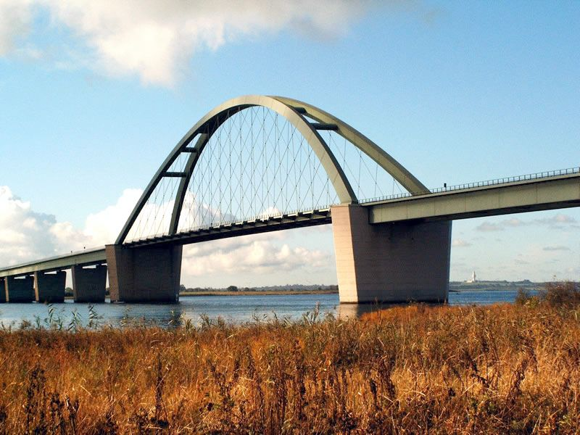
Fig. 31. The Fehmarn Sound Bridge in Northern Germany has a span of 248 m. It is a bridge for road and rail. It was opened in 1963 like my first network arches. The idea of the crossing hangers probably came from my work in Germany in 1955 to 1956. (Stein Ph 1951, Stein & Wild 1965)
图.31 位于德国北部长248m的Fehmarn Sound桥。这是一座公路铁路两用桥。如同我的第一座网状系杆拱桥一样，这座桥也是1963年建成。交叉吊杆的设计思路有极大可能是来自我1955至1956年在德国的工作成果。(Graβe et al 2007)
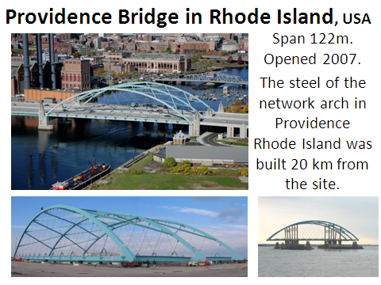
Fig. 32. Here is a network arch that was built in Providence in Rhode Island in the United States. The bridge was opened in 2007. The span is 122 m
图.32 位于美国罗德岛州Providence的一座网状系杆拱桥。这座桥于2007年建成。桥跨122m。

The bridge has 5 traffic lanes in each direction. The steel skeleton was built on a quay 20 km from the bridge site. Then it was rolled onto pontoons and floated to the bridge site. (Steere &Wu 2008)
这座桥具有双向10车道。钢结构骨架在距离桥20km的码头修建。接着被装在浮船运送至桥的位置。

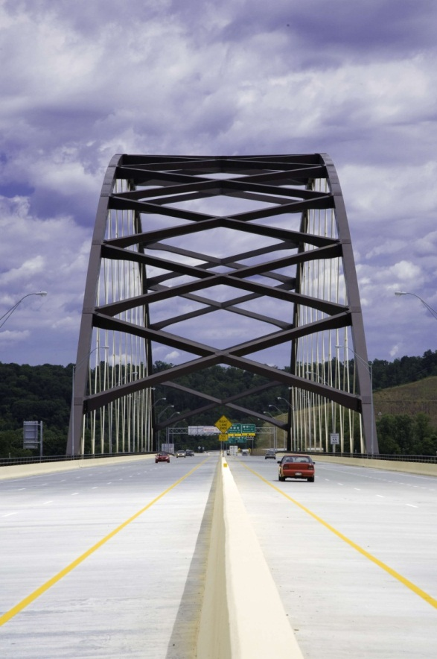
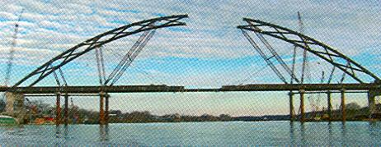

Fig. 33. The Blennerhassett Bridge over the Ohio River is the world’s longest network arch. It has a span of 268 m. (Wollmann & Zoli 2008)
图.33 位于俄亥俄河之上的Blennerhassett是世界上最长的网状系杆拱桥。主跨268m。

During erection the river had to be kept open for traffic. The bridge was opened in 2008. All hangers have a slope of 63.6°. The rise of the arch is 0.2 times the span.
在这座桥架设过程中，河流需要保持航道开放。这座桥2008年建成。所有的吊杆的倾斜角度为63.6°。矢高是跨长的0.2倍。

The use of inclined instead of vertical hangers reduced the live load deflection by a factor of 11. Bending moments in the arch and the tie were reduced by a factor of 4 and 5.
用倾斜的吊杆取代竖直吊杆降低了11倍的（活载挠度live load deflection）。主拱和系杆的弯矩分别降低了4倍和5倍。(Wollmann & Zoli 2008)
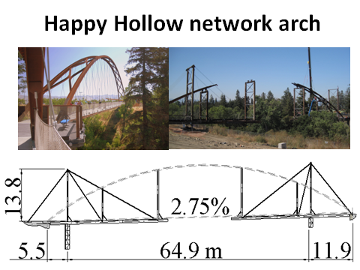
Fig 34. The Happy Hollow pedestrian bridge in San Jose in California is shown in this picture. The first design for the site was a cable stayed bridge that was far over budget. The network arch that was built was designed by HNTB Corporation.
图.34 位于加利福尼亚圣州何塞的Happy Hollow 人行桥。这座桥最初的斜拉桥设计方案由于超预算而被放弃。这座网状系杆拱桥由HNTB公司了的设计完成。
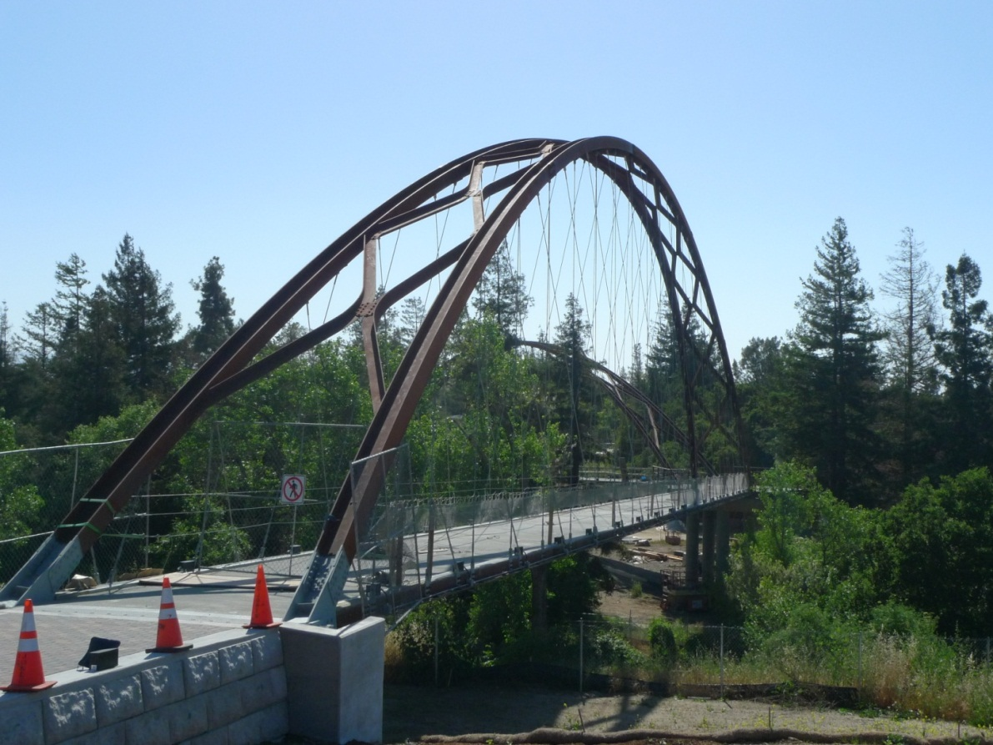
Fig. 35. Pedestrian Bridge in San Jose in Calafornia
The cost was about 50 % less. The steel is slow corroding. The railings are a net. The top of the net is a wire fastened to the hangers.
图.35 加利福尼亚州圣何塞的人行桥。该桥造价节约了50%。钢材受腐蚀较慢。栏杆是网状的。网状的顶部是一条固定在吊杆上的绳索。
Fig. 36. Mangamahu Bridge in New Zealand. (Chan & al, 2008)
图.36 位于新西兰的Mangamahu桥

The picture was taken one year after the author visited New Zealand. It shows a situation in the erection of the Mangamahu Bridge. The span is 85 m. It was opened in 2008.
这张照片是在作者访问新西兰一年后拍摄的。图中展示了Mangamahu的架设场景。这座桥跨长85m。于2008年建成。

The two red cranes each lift half of the arch. The yellow crane lifts the two men that join the arch at the top. The network arch replaced a two span bridge that was swept away by a flood. The native Maoris appreciate that the bridge does not disturb the spirits of the river.
两个红色的吊车分别架设一半的主拱。黄色的吊车将连接主拱的工人升起。这座桥取代了一座被洪水冲垮的（双跨度桥two span bridge）。当地的毛里人喜欢这座桥，因为它没有侵犯河水的灵魂。
Here is a list of conclusions after 57 years working with network arches.
以下是我在57年中对网状系杆拱的工作的一些经验总结。
A well designed network arch is likely to remain the world’s most slender tied arch bridge.
所有设计良好的网状系杆拱桥都可能是世界上最纤细的吊杆拱桥。
The slim chords are pleasing to the eye and do not hide the landscape or cityscape behind them.
纤细的系杆看起来赏心悦目，同时不会遮挡身后的自然景观和城市风光。
The slim tie is sometimes an advantage when there is traffic under the bridge.
当桥下有交通时，纤细的系杆有时具有很大优势。
Small and vertical reactions give savings in the substructure.
较小和竖向的反力，可以为下部结构节省造价。
If the bridge has less than 15-20 m between the planes of the arches, then the lower chord can be a simple concrete tie.
如果两个主拱间距小于15-20m，系杆可以是一个简单的混凝土系杆。
Concrete ties should have small edge beams with room for the longitudinal prestressing cables.
混凝土系杆应当采用小的边梁，只要保留足够的纵向预应力线缆的空间。
If the distance between the arches is more than 10 m, transversal prestressing should be considered.
如果主拱间距大于10m，可以考虑采取横向预应力。
Network arches have small bending moments in the chords.
网状系杆拱桥的系杆弯矩很小。
Network arches are well suited as bridges for roads, rail and footpaths.
网状系杆拱桥十分适于公路，铁路以及人行道的桥梁。
All structural members efficiently carry forces that cannot be avoided in any simply supported beam.
所有的结构组件有效的承载了力，这些力在所有的简支梁中都不可避免。
Tie and hangers give the arch good support and high buckling strength in the plane of the arch.
系杆和吊杆给予主拱良好的支撑，并且让主拱平面内产生良好的抗弯强度。
Tension is predominant in tie and hangers.
拉力主要存在于系杆和吊杆上。

Arches made of H-beams with horizontal webs have a favourable distribution of stiffness and give simple details.
具有水平（腹板web）的（工字梁H-beam）构造的主拱带来良好的刚度分布，并且构造细节简单。
All hangers can have nearly the same cross-section.
所有的吊杆都有几乎相同的界面。
Efficient methods of erection are available.
可采取高效的架设方法。
Erection can be done using a temporary lower chord which combined with the structural steel has enough strength and stiffness to carry the casting of the concrete tie.
架设过程过可以使用临时的系杆，这些系杆与具有足够强度和硬度的结构钢组合在一起，从而承受混凝土系杆的浇筑。

Network arches are not sensitive to uneven settlements in the foundations.
网状系杆拱桥对桥基处的不均匀沉降不敏感。
High strength and low weight give the network arch good resistance to earthquakes.
高强度和轻重量使得网状系杆拱桥有良好的抗地震作用。
Most concrete parts usually need more maintenance than a concrete slab with a slight prestress.
大多数混凝土部分通常比采用少量预应力的混凝土板需要更多的养护。
Network arches should have small surfaces that need little corrosion protection.
网状系杆拱桥应当具有小的表面，这样只需少量防腐蚀保护措施。
High strength steels are well utilised.
更好的利用了高强度的钢材。
If things go well, the network arch can save up to 40% of the cost and 70 % of the structural steel.
如果一切顺利，网状系杆拱可以节约最多40%的造价，70%的结构用钢。

A high percentage of the cost will be labour.
人力成本是占据桥梁造价的很大比重。
Conservatism and lack of time are important obstacles to the building of network arches.
对建造网状系杆拱桥来说，守旧主义和时间紧迫性是两个很大的障碍。

Being over 80 years old, the author feels that his contributions to the future development of network arches will be minor. He would like to point out uses of network arches that deserve to be examined more closely.
作者已经80岁高龄，他感到他对网状系杆拱桥未来发展所能够做出的贡献并不会太多。他更愿意指出的是，对网状系杆拱桥的使用值得更进一步的研究。

- All concrete network arches cast on shore and placed on pillars by big floating cranes.
所有的混凝土网状系杆拱桥在岸上浇筑，并且由大型起重船安装就位。

- Network arches for high speed trains. The considerable stiffness of network arches makes them suitable for this kind of bridges.
网状系杆拱桥适于高速铁路。网状系杆拱桥的高刚度使它非常适于建造高速铁路桥。

- The effect of many hangers relaxing in network arches.
网状系杆拱桥中过多的吊杆放松带来的影响有待研究。

4. Erection of network arches where the arches are steel tubes and temporary lower chords are used. This steel skeleton is lifted onto the pillars. Then the steel tubes are filled with concrete. When the concrete has hardened, the concrete tie can be cast.
在网状系杆拱桥的架设中，使用钢管主拱和临时系杆。这种钢架安装在桥墩上。然后在钢管中灌注混凝土。当混凝土凝结后，可以浇筑混凝土结构的系杆。

5. Temporary network arches for spans from 60 to 120 m assembled from standard components up to 15 m long. These arches could be used for spans too long for the Bailey bridges from the Second World War.
跨度介于60至120m之间的临时网状系杆拱桥，由最长15m的标准组件安装完成。从二战时期起，这些拱桥可以用于更长的，Bailey活动便桥所不能达到的跨度。

From the autumn of 2012 this lecture can be found at my home page http://home.uia.no/pert
Then it will contain many more references.
在2012年的秋季学期，这个讲座内容会出现在我的主页http://home.uia.no/pert中。到时候会有更多的参考文献在其中。

Later there will be some alterations. I would be thankful for your suggestions.
讲座内容今后会有一些 变动。我很希望 大家能够提出建议 。

I am extremely grateful for the help with the translation from Zhaohan Jia and the representative of T.Y.Lin.
我很感谢贾兆晗同学以及(T.Y.Lin林同棪公司)的代表在中文翻译工作上的帮助。

Literature.

The list also contains titles not mentioned in this publication.

Bast “Leitfaden zum Anhang II-H, Hänger von Stabbogenbrücken, des DIN-Fachberichtes 109 (Ausgabe 2008)” Instructions on hangers in tied arch bridges.
Berger, O. (1955) ”Beurteilung des Tragvermögens einer Großen Eisenbahnbrücke auf Grund von Spannungsmessungen und Berechnung als hochgradig (38 fach) statish unbestimmtes System“. (Evaluating the load carrying capacity of a big railway bridge and calculating it as a highly (38 times) indeterminate system. In German.) pp. 526-535.Bauplanung – Bautechnik H. 12 Des.1955. ISBN: 624.21 : 625. 183.3
Bretting, A.E. (1935). ”Inclined Hangers Impart Slenderness to Ribs of 470-Ft. Concrete Arch”. Engineering News-Record. April 25, 1935. pp. 577-580.
Bretting, A.E. (1936). “Über Bogentrträger mit schräg gestellten Hangestängen.” (“On arches with inclined hangers,” in German.) Internat. Vereiniung für Brückenbau und Hochbau. Zweiter Kongress, Schlussbericht 1936. pp. 514-515.
Brunn, B. and Schanack, F. (2003) “Calculation of a double track railway network arch bridge applying the European standards“ Graduation thesis at TU-Dresden. August 2003. 320 pages. A revised version of this thesis can be found at http://home.uia.no/pert/ under the button „Masters Theses“.
Brunn, B., Schanack, F., Steimann, U, (2004) “Network Arches for Railway Bridges.” Arch Bridges IV, Barcelona, Nov. 2004. Advances in Assessment, Structural Design and Construction. P. Roca and C. Molins (Eds.). pp. 671-680. ISBN: 84-95999-63-3
Chan, M., Presland, Rob., Romanes, Mike. (2008) “New Zealand’s First Network Arch Bridge.“ Conference paper for the 4th New Zealand Metal Industry Conference, hosted by HERA in October 2008. All conference papers were published on a CD.
Fiedler, E. and Ziemann, J. (1997), “Die Bogenbrücke über die Saale bei Calbe – eine Brücke mit besonderer Bogenform”, (The Arch Bridge over the Saale River at Calbe – a Bridge with an Unusual Arch Shape. In German.), Stahlbau, Vol. 66, No. 5, 1997, pp. 263-270, Dokumentation 1997, pp. 329-337, ISBN 3-927535-04-4.
Geißler, K., Steimann, U., Graße, W. (2008) “Netzwerkbogenbrücken – Entwurf, Bemessung, Ausfürung” (Network Arch Bridges – Design and Execution.) Stahlbau H. 3, 2008 pp. 159-171.
Graße, W., Teich, W., Tveit, P., Wendelin, S. (2004) Arch Bridges IV, Barcelona, Nov. 2004. Advances in Assessment, Structural Design and Construction. P. Roca and C. Molins (Eds.). pp. 681-690. ISBN: 84-95999-63-3
Graβe, W. and Tveit, P. (2007) “Netzwerkbogenbrücken – Geschichte, Tragwerhalten und ausgeführte Beispiele“ (Network Arches – History, Function and Built Examples. In German.) 17. Dresdner Brückenbausymposium. 13. March 2007. ISSN 1613-1169, ISBN 3-86005-542-9. pp. 183-198.
Günter, G., Hortmanns, M., Schwartzkopf, D., Sedlacek, G. and Bohmann, D. ”Dauerhafte Ausfürung von Hängeranschlüssen an stahlerne Bogenbrücken”. (Durable Attachment of Hangers in Steel Arch Bridges.) Stahlbau 69 (2000) Heft 11, pp. 894 – 908.
Herzog, Max. (1975). “Stahlgewichte moderner Eisenbahn- und Straβenbrücken.” (Steel Weights of Modern Rail and Road Bridges.) Der Stahlbau 9/1975. pp. 280-282.
Kahman, R. and Beisel T. (1979) “Eine außergewöhnliche Montagemethode für die Bogenbrücke bei Straubing.” Der Stahlbau 1979. Heft 4. Berlin. pp. 110-115.
Krück G. E. (1946) “Eisenbeton-Strassenbrücke über den Mänam Pasak bei Ayuthia, Siam.” (“Concrete road bridge over the Mänam Pasak at Ayutia, Siam,” in German.) Schweizerische Bauzeitung 1946. Vol. 127, pp. 139-146, Vol. 128, pp. 6-9, 15-19, 27-28.
Leonhardt, (1991) “Developing guidelines for aesthetic design.” Bridge aesthetics around the world, M. P. Burke Jr. et al.,eds., Nat. Res. Counsil, Washington, D.C. pp. 32-57.
Nakai, H. et al. (1995) “Proposition of Methods for Checking the Ultimate Strength of Arch Ribs in Steel Nielsen-Lohse Bridges.” Stahlbau 64 (1995) Heft 5, pp.129-137.
Naruoka, M., Itoh, K., and Matsukawa, A. (1977) “Nielsen System Bridges in Japan.” Pfluger-Festschrift Hannover, Germany, 1977. pp. 193-202.
Nielsen, O. F. (1929) “Foranderlige Systemer med anvendelse på buer med skraatstillede Hængestenger.” (“Discontinuous systems used on arches with inclined hangers”, in Danish.) 121 pages. Gad Copenhagen. Ph.D. thesis.
Nielsen, O. F. (1932) “Bogenträger mit Schräg gestelten Hängestangen.” (“Arches with inclined hangers,” in German.) Internationale Vereiningung f. Brückenbau und Hochbau. Abhandlungen 1, 1932. pp. 355-363.
Nielsen, O. F. (1936) Same title and periodical as above. Abhandlungen 4, 1936, pp. 429-438.
Ostenfeld, C. (1976) “Christiani & Nielsen, Jernbetonens danske pionerer” (“Christiani & Nielsen, The Danish Pioneers of Reinforced Concrete,” In Danish.) Polyteknisk Forlag, Lyngby, Denmark. 245 pages.
Räck, M. (2003) “Entwurf einer kombinierten Straßen-Eisenbahn-Netzwerkbogen-brücke“ (Draft of a Network Arch for a Combined Road and Railway Bridge) Graduation thesis at TU-Dresden. August 2003. 237 pages. A revised version of this thesis can be found at http://home.uia.no/pert/ under the button ”Masters Theses”.
Šašek. L. (2005). “Getting on the Network. Innovation in arch design” BRIDGE Design § Engineering. v. 11, no 40, pp. 39-40
Šašek. L. (2006). “Less is More“, Civil Engineering, The magazine of the American Society of Civil Engineers - ASCE, April 2006, pp. 50-55.
Schanack, F. (2008) “Puentes en Arco Tipo Network“ (Network Arch Bridges) Doctoral Thesis. Departemento de Ingenieria Estrutural y Mecánica, Escuela Técnica de Caminos, Canales y Puertos, Universitad de Cantabria, Santander, Espãnia, 2008. 370 pages.
Schanack, F. (2008a) “ Puentes en Arco Tipo Network. Network Arch Bridges. Tesis doctoral. Departemento de Ingeneria Estructural y Mecánica, Escuela Técnica Superior de Ingeniería de Caminos, Canales y Puertos. Universidad de Cantabria, Santander 2008.
Schanack, F. and Brunn, B. (2009): “Analysis of the structural performance of network arch bridges” The Indian Concrete Journal 83(1), ACC limited, 2009. pp. 7-13.
Schanack, F. and Brunn, B. (2009a) “Netzgenerierung von Netzwerkbogenbrücken“ (“Creation of hanger arrangements of Network arches“ In German.) Stahlbau 2009. H7. pp. 477-483.
Schlaich J., Fackler T., Weißbach M., Schmitt V., Ommert C., Marx S., Krontal L. (2008) ”Leitfaden Gestalten von Eisenbahnbrücken” (Guide for the Design of Railway Bridges. In German) Fischer Druck GMBH, Peine
Steere, P. and Wu, Y (2008) ”Design and Construction of the Providence River Bridge” 25th Annual International Bridge Conference Engineers' Society of Western Pennsylvania Pittsburgh (PA). June 2-4, 2008. 8 Pages.
Steimann, U. (2002) “Berechnung und Konstruktion einer stählernen Eisenbahn-Stabbogenbrücke mit Netzwerkhängern“ (Calculation and Design of Network Arch Railway Bridge of Steel. In German.) Graduation thesis at TU-Dresden. September 2002. 270 pages. A revised version of this thesis can be found at http://home.uia.no/pert/ under the button “Masters Theses”.
Stein, Ph. (1951) “100 Jahre GHH” (“100 Years of GHH Bridge Building”) Publisher: Gutehoffnungshütte Aktiengesellschaft, Oberhausen.
Stein, Peter and Wild, H. (1965). “Das Bogentragwerk der Fehmarnsundbrücke.” (“The arch of the Fehmarnsound Bridge” In German.). Der Stahlbau, 34(6) Berlin, B.R.D. pp. 71-186.
Teich, S. (2004) “Fatigue Optimization in Network Arches” Arch Bridges IV, Barcelona, Nov. 2004. Advances in Assessment, Structural Design and Construction. P. Roca and C. Molins (Eds.). pp. 691-700. ISBN: 84-95999-63-3.
Teich, S. and Graβe, W. (2004a) “Beitrag zur Optimierung von Hängeranschlüssen Stählerner Stabbogenbrücken” (“Contribution to the optimisation of ends of hangers in steel arch bridges” in German) Stahlbau, 2004, H. 12. pp. 1021-1030.
Teich, S. and Wendelin, S. (2001) „Vergleichsrechnung einer Netzwerkbogenbrücke unter Einsats des Europäishen Normenkonsepts.“ (In German). Graduation thesis at TU-Dresden. August 2001. 300 pages. A revised version of this thesis can be found at http://home.uia.no/pert/ under the button ”Masters Theses”.
Teich, S. (2012) “Beitrag zur Optimierung von Netzwekenbogenbrüken“ (Contribution to Optimizing Network Arch Bridges). PhD. Thesis. ISSN 1613-6934.
Tveit, P. (1959) “Bogebruer med skrå krysstilte hengestenger.” (“Arch bridges with inclined intersecting hangers,” in Norwegian.) Ph.D. thesis presented at the Tech. Univ. of Norway. 64 pages, 78 drawings.
Tveit, P. (1964) “Nettverkbogar, ein ny brutype”. (“Network Arches, a New Type of Bridge.) Bygg, Vol. 12, May 1964, pp.105-113.
Tveit, P. (1966) “Design of Network Arches.” Struct. Eng:, 44(7). London, England, pp. 247-259.
Tveit, P. (1973) “Network arch in double track railway bridge.” Presented at Nordic Research. Days for Steel Struct., held in Oslo, Norway, Pre-print V713. (The publication is much the same as: “Report 7205.” Ren og Anvendt Mekanik, Danmarks Ingeniørakademi, Bygningsafdelingen, Aalborg, Denmark. 35 pages.
Tveit, P. et al. (1978) “Network arches.” 1st ed., Civil Engineering. Department., Univ. of Houston June 26 1978. 93 pages. Revised edition reprinted at inst. of Bldg. Techn. Struct. Engrg., Aalborg Univ. Centre Aalborg, Denmark, 1980. ISSN 0105-8185 NOTE NO. 8007. Including handout for the Poster Session of IABSE’s 11. Congress, Vienna, September 1980. 45 pages.
Tveit, P. (1980a) “Network arches.” Handout for poster session of IABSE’s 11th Congress, held at Vienna, Publ. by inst. Tech. Struct. Engineering., Aalborg Univ. Centre, Aalborg, Denmark. 45 pages.
Tveit, P. (1980b) “Network Arches.” 11th IABSE Congress, held in Vienna, Austria, Final Report, IABSE, ETH-Hönggerberg, CH-8039, Zürich, Switzerland, pp. 817-818.
Tveit, P. (1981) “25 år med nettverkbogar. Resultat og perspektiv.” (“25 years with network arches. Results and perspectives,” in Norwegian.) Guest lect. at Tech. Univ. of Norway, printed at Inst. of Bldg, Tech. Struct. Engineering., Aalborg University. Aalborg, Denmark. 40 pages. IFB/A 8101.
Tveit, P. (1984) “Economic design of network arches” Handout for the poster session of IABSE’s 12th congress, Vancouver, September 1984. Published by Inst. Bldg. Tech. Struct. Engineering., Alborg Univ. Centre, Aalborg. 32 pages. ISSN 0105-7321 R8405.
Tveit, P. (1984a) “A network arch with four sets of hangers designed to be cast and erected on ice floating between piers.” Handout for the poster session of IABSE’s 12th Congress, held at Vancouver, Canada. Publ. by Inst. of Bldg. Tech. Struct. Engineering., Alborg Univ. Centre, Aalborg, Denmark. 106 pages.
Tveit, P. (1987) “Considerations for the Design of Network Arches.” Journal of Structural Engineering, Vol. 1113, No.10, October, 1987. ©ASCE, ISSN 0733-9445/87/0010-21897 Paper No. 21892. pp. 2189-2207.
Tveit, P. (1992) “Network Arches in Perspective” Guest Lecture held at the technical Universities in Prague and Vienna, March 1986. Published by Agder College of Engineering, Norway. Report 2/92 ISSN 0801-6313, 36 pages

Tveit, P. (1999a) Comparison of Steel Weights in Narrow Arch Bridges with Medium Spans. A Note on the Optimal Design of Network Arches. Published by Agder University College. Publication Series No. 47. 8 pages. Issn: 0806-5942 Isbn: 82-7117-378-2.
Tveit, P. (1999b) Netværksbuer – en interessant brotype. Foredrag i København, Gøteborg og NTNU. March 1999. (Network arches – an interesting type of bridge. Lectures in Copenhagen, Gothenburg and NTNU. March 1999). Published by Agder University College 1999. 30 pages. ISSN: 0806-5942, ISSN: 0806-5942, ISBN: 82-7117-394-4.
Tveit, P. (1999c) “Comparison of Steel Weights in Narrow Arch Bridges with Medium Spans” Stahlbau (1999) H9. pp. 753-757.
Tveit, P. (2000) A bridge suitable for India? ICI journal, Indian Concrete Institute. Vol. 1, April – June 2000 no.1, pp. 7-10.
Tveit, P. (2001) “How, Why and Where for the Network Arch, the World’s Most Slender Arch Bridge.” Contribution to ARCH’01. Third international arch bridge conference. pp. 161-167. ISBN 2-85978-347-4.
Tveit, P. (2002) “Optimal design of network arches”. Contribution to the IABSE Symposium in Melbourne 2002. 13 pages. ISBN 3-85748-107-2
Tveit, P. (2002a) “The Network Arch. Annual lecture of the ICI”. Deliverered at the Annual Seminar of the Indian Concrete Institute in New Delhi in 2002. pp. 1-103.
Tveit, P. (2002c) “Konstruksjon av ein optimal nettverkboge med vekt på produksjons- og vedlikehaldskostnadar” (Design of an optimal network arch, stressing cost of production and maintenance. In Norwegian.) Brukonferansen 2002. Moderne stålbruer. Vika atrium I Oslo 30. – 31. October. Published by Statens vegvesen, Vegdirectoratet
Tveit, P. (2003) “Preliminary Design of Network Arch Bridges” The Bridge & Structural Engineer. Workshop on Innovation in Bridge Engineering, New Delhi, March 22-23, 2003. pp. I-1 to I-17
Tveit, P. (2003a) “Erection of Optimal Network Arches” Contribution to 8th International Conference on Innovation and Planning, Design and Construction Techniques in Bridge Engineering.” Organised by : Indian Institution of Bridge Engineers. 26-27 April, 2003. Hyderabad, India. Vol.1 pp. 1-27
Tveit, P. (2003b) “Competitive Design of Network Arches”. In: Structural Research. Anniversary volume honouring Péter Lenkei. Bársony, J. Ed. Pollack Mihály Faculty of Engineering. Pécs University, Hungary. pp. 225-233.
Tveit, P. (2004) “Introducing the Optimal network arch.” Bridges in the Danube Basin. Procedings of the 5th International Conference on Bridges across the Danube 2004. Novi Sad/Serbia & Montenegro/ 24 – 26 June 2004. Bratislav Stipanic. Ed. Pub. by Euro Gardi Group, Rumenacka 17, Novi Sad. pp. 257-266
Tveit, P. (2004a) “Reduce Costs by Building Optimal Network Arches” Keynote lecture at Arch Bridges IV, Barcelona, Nov. 2004. Advances in Assessment, Structural Design and Construction. P. Roca and C. Molins (Eds.). pp. 26-37. ISBN: 84-95999-63-3
Tveit, P. (2004b) “Network arches for road bridges.” Co-authors: Wolfgang Graβe, Stephan Teich, Stephan Wendelin. Arch Bridges IV, Barcelona, Nov. 2004. Advances in Assessment, Structural Design and Construction. P. Roca and C. Molins (Eds.). pp. 681-690. ISBN: 84-95999-63-3
Tveit, P. (2004c) “Erection of network arches.” Co-authors: Mathias Räck, Frank Schanack. Arch Bridges IV, Barcelona, Nov. 2004. Advances in Assessment, Structural Design and Construction. P. Roca and C. Molins (Eds.). pp. 661-670. ISBN: 84-95999-63-3
Tveit, P. (2004d) “Optimal Network Arches for Rail and Road Bridges.” 9th International Conference on Current Trends in. Aqueducts, Road, Rail and Marine Bridges, 20-22 December 2004.– Hyderabad, India. Organised by: Indian Institution of Bridge Engineers. pp.185-195.
Tveit, P. (2005) “Optimal Network Arches for Rail and Road Bridges” Contribution to 4th International Conference on New Dimensions in Bridges, 24-26 October 2005 in Fuzhou, China.
Tveit, P. (2006) “Optimal Network Arches for Coastal Regions”. International conference on bridges, Dubrovnik, May 2006. pp. 721-728. ISBN953-95428-0-4
Tveit, P. (2007) “Visit to the Steinkjer network arch 44 years later”. ARCH’07, 5th International Conference on Arch Bridges. Madeira, 12-14 September 2007. pp. 305-314, © University of Minho. Portugal. ISBN: 978-972-8692-31-5
Tveit, P. (2008a) “Concrete in the optimal network arch.” Proceedings of the International fib Symposium 2008, Amsterdam, 19-21 May 2008. Editors: Walraven, J. and Stoelhorst, D. p. 164.
Tveit, P. (2008b).”The Network Arch and how to Erect it.” Żabljak,03-07. Marta 2008. Univerzitet Crne Gore, ISBN 987-86-82707-14-1
Tveit, P. (2008c) “About The Network Arch”. This is a lecture that IABSE has asked the author to give for a group of lectures that can be found at http://elearning-iabse/l20 Can also be found at the author’s home page http://home.uia.no/pert/ under the button ”My Publications”.
Tveit, P. (2008d).”India Needs Network Arches” Contribution to national seminar on “Recent Advances and Future Trends in the Design and Construction of Bridges.” 11-13 July, 2008. Organised by; National Bridge Research & Development Center, Hyderabad, Indian Institution of Bridge Engineers, Mumbai. Published by The Indian Institution of Bridge Engineers, 9,Gr. Fl.Greenfield CHS, Off Sitaladevi Tempel Road,Mahim, Mumbai-400 016, E-mail: iibe@vsnl.com. pp. 29-46.
Tveit, P. (2009a) “Submerged Floating Tunnels for Norwegian Fjords.” Proceedings of the fifth Symposium on Strait Crossings, Trondheim, Norway June 21-24, 2009. ISBN 978-82-92506-69-1 pp. 515-520.
Tveit, P. (2009) “Efficient Utilisation of Network arches.” Proceedings of the fifth Symposium on Strait Crossings, Trondheim, Norway June 21-24, 2009. ISBN 978-82-92506-69-1 pp. 509-514.
Tveit, P. (2009) “India Needs Network Arches”. Civil Engineering & Construction Review. New Delhi, August 2009. Pp. 50-60.
Tveit, P. (2010) “Optimal network arches for road and rail bridges”. ARCH’10. 6th International Conference on Arch Bridges. Fuzhou, Fujian, China. October 11-13, 2010. Editors Baochun Chen, Jiangang Wei. pp. 271 – 277.
Tveit, P. (2010a) “Submerged floating tunnels (SFTs) for Norwegian Fjords”. Proceedings of First International Symposium on Archimedes Bridge (ISAB-2010). In China. Published by Elsevier. pp. 135 – 143.
Tveit, P. (20011) “The Network Arch. Bits of Manuscript in Feburary 2011 after Lectures in 50 Countries.” Can be found at http://home.uia.no/pert/ under the button ”The Network Arch”.
Yoshikava, O. et al. (1993) “Construction of the Shinamadera Bridge” Stahlbau 63 (1993), Heft 5, pp.125-136.
Wollmann, G. et al. (2007) “Construction of Tied Arch Bridge Across Ohio River and Blennerhassett Island” Proceedings, 24th Annual International Bridge Conference, Pitsburgh, Pennsylvania, June 4-6
Wollmann, G., Zoli, T., (2008) “Bridge Across Ohio River and Blennerhassett Island”. Structural Engineering International, Vol. 18, No.1, Feb. 2008, p. 28 – 30.
Zoli, T. and Woodward, R. (2005) “Design of Long Span Bridges for Cable Loss.” IABSE Symposium, Structures and Extreme Events, September 14-17, Lisbon, Portugal.
Zwingmann, B., Schanack, F. and Marx, S. (2009) “Asymetrische Netzwerkbogenbrücken Stahlbau” H. 7 pp 471 - 476.

